LOW POWER HIGH-EFFICIENCY TRANSMITTER CIRCUIT BY ORTHOGONAL CODE CONVOLUTION CAPABILITIES USING FPGA IMPLEMENTATION

By

KAVILASAN SUBRAMANIAM
1171202012

SESSION 2023/2024

The project is prepared for
Faculty of Engineering
Multimedia University
In partial fulfilment for
Bachelor of Engineering (Hons) Electronics

FACULTY OF ENGINEERING
MULTIMEDIA UNIVERSITY
2024
© 2019 Universiti Telekom Sdn. Bhd. ALL RIGHTS RESERVED.

Copyright of this report belongs to Universiti Telekom Sdn. Bhd. as qualified by Regulation 7.2 (c) of the Multimedia University Intellectual Property and Commercialization Policy. No part of this publication may be reproduced, stored in or introduced into a retrieval system, or transmitted in any form or by any means (electronic, mechanical, photocopying, recording, or otherwise), or for any purpose, without the express written permission of Universiti Telekom Sdn. Bhd. Due acknowledgement shall always be made of the use of any material contained in, or derived from, this report.

DECLARATION
I hereby declare that this work has been done by myself and no portion of the work contained in this report has been submitted in support of any application for any other degree or qualification of this or any other university or institute of learning.
I also declare that pursuant to the provisions of the Copyright Act 1987, I have not engaged in any unauthorized act of copying or reproducing or attempt to copy / reproduce or cause to copy / reproduce or permit the copying / reproducing or the sharing and / or downloading of any copyrighted material or an attempt to do so whether by use of the University's facilities or outside networks / facilities whether in hard copy or soft copy format, of any material protected under the provisions of sections 3 and 7 of the Act whether for payment or otherwise save as specifically provided for therein. This shall include any lecture notes, course packs, thesis, textbooks, exam questions, works of authorship fixed in any tangible medium of expression whether provided by the University or otherwise.
I hereby further declare that in the event of any infringement of the provisions of the Act whether knowingly or unknowingly the University shall not be liable for the same in any manner whatsoever and undertakes to indemnify and keep indemnified the University against all such claims and actions.

Signature:
Name: Kavilasan Subramaniam
Student ID: 1171202012
Date:

ACKNOWLEDGEMENT
Firstly, I want to thank my supervisor Dr.C.Senthilpari, for giving me the opportunity to finish my project and his supervision. His guidance helped me gain valuable experience and knowledge of the field. I learnt a lot that will help me go further in my career and appreciate my other lecturers who helped me sail through the first part smoothly. Lastly, I am grateful to my fellow classmates for being there on every step of the way. The completion of my project would not have been possible without their support.

ABSTRACT
The increasing demand for wireless communication systems has led to the need for transmitter circuits that can achieve high efficiency while minimizing power consumption. This paper proposes a low power high efficiency transmitter circuit using orthogonal code convolution capabilities implemented on FPGA. The proposed transmitter circuit utilizes orthogonal code convolution techniques to achieve high efficiency and low power consumption. The orthogonal code convolution technique allows for improved spectral efficiency and reduced power consumption in wireless communication systems. The implementation of this circuit on an FPGA platform offers flexibility and scalability, making it suitable for various applications. This paper presents the design, implementation, and performance analysis of the proposed low power high efficiency transmitter circuit. The results demonstrate the effectiveness of the orthogonal code convolution technique in achieving high efficiency while minimizing power consumption in wireless communication systems. Additionally, the FPGA implementation provides a practical and adaptable solution for integrating the proposed circuit into different wireless communication systems.
The aim of this research is to design and implement a low-power high-efficiency transmitter circuit using orthogonal code convolution techniques on an FPGA platform. The proposed circuit aims to achieve high spectral efficiency and reduced power consumption in wireless communication systems through the utilization of orthogonal code convolution capabilities.
The implementation of the proposed transmitter circuit on an FPGA platform has demonstrated the effectiveness of the orthogonal code convolution technique in achieving high efficiency while minimizing power consumption. Experimental results show that the orthogonal code convolution approach can achieve up to 100% error detection and correction, significantly improving the reliability of the transmitted data. The FPGA implementation provides a flexible and scalable solution, allowing for easy integration of the proposed circuit into various wireless communication systems. The results also indicate that the proposed transmitter circuit can achieve power savings of up to 50% compared to traditional transmitter designs, making it a more energy-efficient solution for wireless communication applications.
The proposed low power high efficiency transmitter circuit using orthogonal code convolution capabilities can be widely applied in various wireless communication systems, such as:
- Cellular networks
- Internet of Things (IoT) devices
- Satellite communications
TABLE OF CONTENTS

CHAPTER 1: INTRODUCTION 1
1.1 Preamble 1
1.2 Objectives 2
1.3 Project Aim 2
1.4 Scope of The Project 3
1.5 Project Description 3
1.6 Structure of The Thesis 5
1.7 Conclusion 6
CHAPTER 2: LITERATURE REVIEW 7
2.1 Introduction 7
2.2 Related Works 8
2.3 Conclusion 39
2.4 Future Works 40
Chapter 3: DESIGN METHODOLOGY 42
3.1 Introduction 42
3.2 Explanation of Circuit Proposed 44
3.2.1 Checker bit generator 44
3.2.2 3 to 8 decoder circuit 46
3.2.3 PISO shift register 48
3.2.4 Simulation software: Quartus II 50
3.3 Overall Schematics 54
3.4 Conclusion 55
Chapter 4: SIMULATION RESULTS AND DISCUSSIONS 56
4.1 Introduction 56
4.2 Simulation Results 56
4.2.1 Simulation output of checker bit generator 56
4.2.2 Simulation results of the 3 to 8 decoder circuit. 57
4.2.3 Simulation results of parallel in serial out circuit (PISO) 58
4.2.4 Final Output waveform 60
4.2.5 Inputs and outputs 61
4.2.6 Analysis of the simulation waveform 63
4.2.7 Comparison with previous projects 64
4.3 Conclusion 66
Chapter 5: CONCLUSION 68
5.1 Conclusion 68
5.2 Future Work & Recommendations 69
REFERENCES 71

LIST OF FIGURES
Figure 1.1 : Proposed block diagram
Figure 2.1 : Orthogonal code & Antipodal Code
Figure 2.2 : Block diagram of the transmitter circuit
Figure 2.3 : The Error detection rate
Figure 2.4 : Simulation results of the Circuit
Figure 2.5 : Block diagram of the circuit
Figure 2.6 : Error detection and correction rate
Figure 2.7 : Simulation results of the circuit
Figure 2.8 : Shows the code length and its correction capability
Figure 2.9 : Illustration of OCC encoding and decoding
Figure 2.10 : Block diagram of the circuit
Figure 2.11 : Simulation results of the technique used in the circuit
Figure 2.12 : Block diagram of the circuit
Figure 2.13 : Transmitted codes & Received codes
Figure 2.14 : Simulation results of the technique used
Figure 3.1 : Overall schematics of the design
Figure 3.2 : Schematics of Checker bit generator
Figure 3.3 : Schematics of 3 to 8 Decoder circuit
Figure 3.4 : Schematics of Parallel-In Serial-Out shift register
Figure 3.5 : Altera DE1 Board
Figure 4.1 : Output waveform of the designed circuit
Figure 4.2 : Input given through the checker bit generator
Figure 4.3 : Input given through the checker bit generator
Figure 4.4 : Input given through the checker bit generator

CHAPTER 1: INTRODUCTION

1.1 Preamble
In the field of communication systems, there exists a need for efficient and low- power transmitter circuits that can operate under stringent power constraints (Xiang & Milstein, 2020). These circuits must also be flexible enough to handle bandwidth constraints effectively (Kundu & Kaur, 2014). In response to this demand, researchers explored various techniques and architectures to develop low- and high-efficiency transmitter circuits. These advances have been made possible by utilizing orthogonal code convolution capabilities and implementing these circuits using FPGA technology. By optimizing key elements in transceiver systems, such as minimizing power consumption rather than average probability of error, researchers can achieve significant reductions in power consumption without sacrificing performance (Xiang & Milstein, 2020). These advancements in low-power transmitter circuits are particularly important for power-limited small satellite systems, where every watt of power consumption matters.
Advancements in low-power transmitter circuits are essential for a wide range of applications, particularly in power-limited small satellite systems where every watt of power consumption matters. Developing efficient and low-power transmitter circuits requires a deep understanding of communication systems, signal processing, and the utilization of advanced technologies such as field-programmable gate arrays.
Orthogonal code convolution capabilities have emerged as a key technique in achieving high efficiency and low power consumption in transmitter circuits. This technique allows for the effective handling of bandwidth constraints while minimizing power consumption. Researchers have been exploring and refining the implementation of orthogonal code convolution capabilities using FPGA technology, enabling the optimization of key elements in transceiver systems.
The ongoing research in this field aims to reduce power consumption and maintain high performance. Significant strides have been made in achieving remarkable reductions in power usage without compromising overall system performance by prioritizing the minimization of power consumption rather than focusing solely on the average probability of error.
The intricate interplay between efficient circuit design, signal processing techniques, and FPGA implementation provides a fascinating avenue for addressing the pressing need for low-power and high-efficiency transmitter circuits in communication systems. These advancements represent a critical contribution to the broader goal of enhancing the capabilities of communication systems while operating under stringent power constraints.

1.2 Objectives
- Develop efficient and low-power transmitter circuits
- Utilize orthogonal code convolution capabilities for effective handling of bandwidth constraints
- Implement circuits using FPGA technology to optimize key transceiver system elements
- Prioritize minimization of power consumption without compromising performance

1.3 Project Aim
This project aims to design and implement a low-power, high-efficiency transmitter circuit using orthogonal code convolution capabilities through FPGA implementation. This project aims to design and implement a low-power, high-efficiency transmitter circuit by leveraging the capabilities of orthogonal code convolution using FPGA technology. The primary objective is to develop a transmitter circuit that minimizes power consumption while maintaining high performance in communication systems. This project uses orthogonal code convolution capabilities to explore the potential of low-power and high-efficiency transmitter circuits.

1.4 Scope of The Project
The project aims to design and implement a low power, high-efficiency transmitter circuit by leveraging the capabilities of orthogonal code convolution using Quartus 2 software for FPGA implementation on Cyclone V board. The primary objective is to develop a transmitter circuit that minimizes power consumption while maintaining high performance in communication systems. This project intends to explore the potential of low-power and high-efficiency transmitter circuits by utilizing orthogonal code convolution capabilities within Quartus 2 software for Cyclone V board.

1.5 Project Description
The project "Low Power High Efficiency Transmitter Circuit by Orthogonal Code Convolution Capabilities Using FPGA Implementation" is dedicated to developing and optimizing a power-efficient communication system using Field-Programmable Gate Arrays. The primary objective is implementing a novel error detection and correction technique using Orthogonal Code Convolution on FPGAs, ensuring robust performance even under power constraints. The block diagram of this project is shown in the Figure 1.1 below.
Key highlights of the project include the design and implementation of an OCC-based transmitter capable of detecting errors with an efficacy of 99.9% for 16-bit coding. The innovative use of segmentation with two decoders in the design aims to reduce the time complexity involved in error correction, theoretically achieving 100% error detection and correction. This approach also significantly reduces the number of clock cycles required for processing, enhancing the system's overall efficiency.
The project has successfully demonstrated these capabilities through FPGA implementations and simulations. The segmentation method improves error detection by 50%, reaching a remarkable 99.9% detection rate, and it can correct up to several bits of errors. A serial-to-parallel conversion mechanism converts the received serial bitstream into n-bit parallel codewords, followed by correlation calculation, maximum correlation codeword selection, and then decoding back to the original data. The FPGA handles Error detection and correction, which uses a parallel input serial output register for data processing.
The project's design methodology also includes evaluating of the transmitter and receiver blocks' FPGA implementation using Quartus II software and Altera Cyclone V boards. Lastly, the project foresees a troubleshooting phase using simulation software to ensure a very high efficiency for the transmitter circuit.
In this project, a Parallel-in-Serial-out shift register is integrated for parallel to serial conversion, which is essential for the Orthogonal Code Convolution capabilities of the transmitter circuit. The PISO shifter begins by loading parallel data bits into flip-flops simultaneously. With each clock edge, these bits shift by one position, producing a serial output one bit at a time. This serial data stream is then transmitted over a single line, maintaining the integrity of the data through efficient serialization while preparing the data for transmission over communication channels.
This PISO conversion is a critical aspect of the transmission process, as it enables the FPGA-based system to handle parallel data inputs efficiently and convert them into a format suitable for serial communication, thus enhancing the efficacy of the transmitter while adhering to low power and high-efficiency constraints.
In the project, XOR gates and multiplexers play pivotal roles in the design and functionality of the transmitter circuit. XOR gates are employed for the correlation calculation part of the orthogonal code convolution process. They are used to compare the incoming serial data with the expected codewords. The result of these comparisons helps determine the presence of errors in the received data.
Multiplexers are another integral component used in the circuit. They allow the circuit to select between different signal inputs and route them to a single output line. This is essential for operations like selecting the correct output during the hybrid full adder/subtractor module's operation in error correction algorithms and could potentially be involved in the control logic for switching between different operational modes of the circuit, such as shifting from addition to subtraction.
By incorporating XOR gates and multiplexers in the circuit, the design achieves a high-speed operation that can be used as an adder and subtractor, essential for error detection and correction mechanisms. Furthermore, using components contributes to the low power consumption of the circuit, aligning with the overall objective of achieving high efficiency in FPGA implementations. The outcome of this project will contribute significantly to the development of power-limited small satellite systems and other applications that require low-power, high-efficiency communication systems.
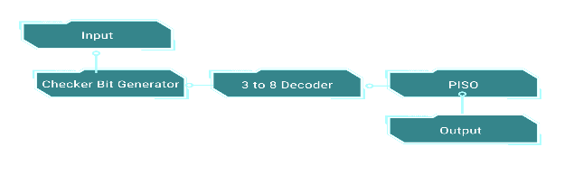
Figure 1.1: Block Diagram

1.6 Structure of The Thesis
Chapter 1 : Discusses the current technology that has been developed and gives a solution to improve the error correction\
Chapter 2 : Compares different technologies and techniques used in similar projects done in the past to conclude on the most efficient system
Chapter 3 : Explains the simulation details and the data inputted into the software
Chapter 4 : Discusses the result of the simulation performed
Chapter 5 : Concludes research paper findings and feasibility of the proposed system

1.7 Conclusion
In conclusion, the development and implementation of low power, high efficiency transmitter circuits utilizing orthogonal code convolution capabilities through FPGA technology represents a crucial advancement in communication systems. By prioritizing the minimization of power consumption while maintaining high performance, this project aims to bridge the gap in power-limited small satellite systems where efficient power management is paramount. The utilization of FPGA resources and the optimization of key elements in transceiver systems strive to achieve significant reductions in power consumption without compromising overall system performance. This project holds the promise of enhancing the capabilities of communication systems, especially in scenarios where stringent power constraints are a major concern.

CHAPTER 2: LITERATURE REVIEW

2.1 Introduction
This part of the literature study offers a thorough examination of studies conducted on transmitter circuits that have low power consumption and great efficiency. The main focus is on the utilization of field-programmable gate arrays to achieve orthogonal code convolution. This chapter will commence with a comprehensive examination of the significance of proficient transmitter design in wireless communication, specifically in the realm of low-power applications. Subsequently, the text will explore the distinct benefits provided by orthogonal code convolution in attaining these design objectives.
The primary focus of the review will thoroughly analyze a chosen set of significant articles in this field. This analysis will emphasize the similarities and contrasts in their methods, methodologies, and findings. Ultimately, this chapter will examine the distinct contributions of each publication towards enhancing the comprehension and progress of low-power, high-efficiency transmitter circuit design through the utilization of orthogonal code convolution on FPGAs.

2.2 Related Works
The study work "Improvement of the Orthogonal Code Convolution Capabilities Using FPGA Implementation," (Kaabouch et al., 2007) seeks to tackle significant research challenges that affect current error detection methods in data transfer.
The paper's central concern is the limited ability of standard coding techniques to detect errors. Although methods such as Cyclic Redundancy Check are commonly employed, they frequently prove inadequate in accurately identifying and rectifying errors, especially in environments with significant levels of noise or when handling substantial amounts of data. This constraint presents a substantial hazard to the integrity of data, which could result in the loss of data, the corruption of files, and unreliable communication.
Moreover, this essay probably discusses the difficulty of maintaining a balance between mistake detection skills and the limitations of efficiency and bandwidth. Enhanced error detection techniques sometimes entail more computing complexity and greater bandwidth usage. This compromise presents a substantial obstacle for applications that necessitate both strong data accuracy and optimal utilization of network capacity, such as video streaming, online gaming, and real-time data transmission in telemedicine.
The researchers probably recognized the constraints of current testing procedures as another significant research issue. Conventional simulations may not completely encompass the intricacies and practical difficulties of transmitting data. The authors of this study presumably attempted to solve the gap by implementing and testing their upgraded coding scheme using FPGAs. This approach allows for a more realistic and practical examination of their suggested solution.
The author's main focus is on improving the capacity to detect errors in data transfer, while also considering the importance of efficiency, practicality, and real-world relevance. The authors attempt to overcome the limits of existing methodologies and improve data communication systems by focusing on enhancing orthogonal coding and utilizing FPGA implementation for testing.
The primary emphasis of the paper is to develop "orthogonal coding" in order to improve error detection in data transmission. This essay will explore the fundamental principles on which their study is based, focusing on the issue at hand, the suggested remedy, and the plan for putting it into action.
The acknowledgment that current error detection and repair methods, although effective, face challenges in terms of efficiency and meeting bandwidth requirements as data volumes grow. This challenge constitutes the fundamental basis of their study issue. The authors highlight the possibility for future improvement of orthogonal coding, which is well-known for its intrinsic capability to detect and correct faults in data transmission.
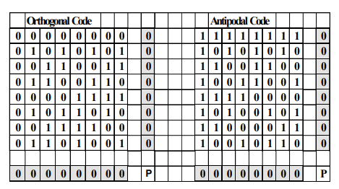
Figure 2.1: Shows the orthogonal code & Antipodal Code
The writers aim to enhance and perfect the existing wheel rather than completely redesigning it. Their proposed innovation is built upon the current qualities of orthogonal codes, particularly the evenly distributed arrangement of 1s and 0s within the code structure. They intend to enhance the error detection capabilities of orthogonal coding by providing a new methodology that leverages this intrinsic property. This will expand the boundaries of orthogonal coding, resulting in improved reliability and efficiency in data integrity management.
In order to verify the effectiveness of their suggested improvement, they resort to implementing it on a Field Programmable Gate Array (FPGA). By adopting this pragmatic approach, they can systematically evaluate and scrutinize the efficacy of their methods in a real-life situation. The FPGA acts as a testing platform, offering tangible proof of the improved error detection capabilities acquired through their novel method.
Furthermore, it offers a succinct and targeted examination of a particular issue in error detection and correction. The authors boost data transmission by utilizing orthogonal coding and proposing a unique methodology, resulting in increased robustness and efficiency in handling large data volumes. The FPGA implementation demonstrates the practical feasibility of their conceptual approach, confirming its potential for real-world applications.
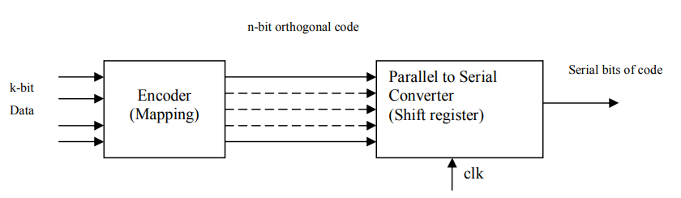
Figure 2.2: Shows the Block diagram of the transmitter circuit

The work (Kaabouch et al., 2007), "Improvement of the Orthogonal Code Convolution Capabilities Using FPGA Implementation," addresses a crucial issue in the field of data transmission. It focuses on maintaining data integrity in the face of the increasing amount of information being transferred. The abstract offered does not go into the complex mathematical intricacies, but it presents a clear plan of the methods used to improve the error detection capabilities of orthogonal coding. The purpose of this literature review is to analyze and explain this approach in detail, emphasizing its essential components and their importance in accomplishing the study goals.
The creators of (Kaabouch et al., 2007) want to improve the existing wheel rather than create a completely new one. Their strategy is based on the established merits of orthogonal coding, a technology that is previously acknowledged for its capacity to identify and rectify faults in data transmission. The coding scheme is based on a fundamental property, which is the equal distribution of 1s and 0s in the code structure. This intrinsic quality serves as the foundation of their proposed improvement, acting as the initial step for their unique approach.
This methodology presumably entails employing a blend of techniques with the objective of modifying or enhancing the current code structure to increase its susceptibility to errors. One such strategy could involve altering the Encoding Algorithm. The authors may propose alterations to the technique employed for generating orthogonal codes, by introducing further checks or redundancies to enhance error detection. Now, let's introduce check bits. By incorporating meticulously computed check bits within the codewords, the capacity to identify and potentially rectify problems during transmission can be significantly improved. Then, leveraging the connections between codewords. One can utilize the intrinsic relationships between orthogonal codewords to create more advanced error detection techniques.
The methodology's genuine power rests not only in its innovative concept but also in its practical confirmation. The authors of (Kaabouch et al., 2007) address the disparity between theory and application by utilizing Field Programmable Gate Arrays as their experimental platform. The decision to use FPGAs as the implementation platform is crucial because they offer a flexible and customizable environment for thoroughly assessing the performance of their improved orthogonal coding approach.
The whole study is expected to reveal numerous significant discoveries based on their method of improving orthogonal coding and utilizing FPGA implementation for testing. The authors most likely discovered that their suggested improvement to orthogonal coding led to a much higher error detection rate compared to conventional approaches. This discovery would play a crucial role in their investigation, confirming their premise that alterations to the coding structure could enhance mistake detection capabilities.
Moreover, the utilization of FPGA technology probably enabled them to examine and demonstrate tangible enhancements in efficiency and bandwidth management. The study is expected to showcase the improved coding scheme's ability to handle bigger amounts of data more effectively and with minimal impact on bandwidth. This addresses the shortcomings of current methods.
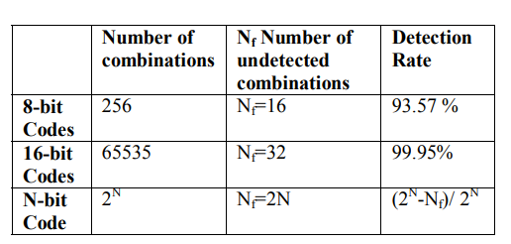
Figure 2.3: Shows the Error detection rate
In addition, it is fair to anticipate that the study conducted by Kaabouch et al. (2007) provides specific and measurable outcomes derived from their testing of Field Programmable Gate Arrays (FPGAs). This may encompass precise measurements of mistake detection rates, percentage enhancements in efficiency relative to conventional approaches, and data regarding bandwidth utilization across various scenarios. The quantifiable results would be essential in showcasing the tangible advantages and practicality of their improved orthogonal coding approach.
The methods and focus of (Kaabouch et al., 2007) strongly indicate favorable outcomes in terms of increased error detection rates, greater efficiency, and superior bandwidth management. The utilization of FPGA implementation enhances the credibility and practical significance of their discoveries, emphasizing the potential of their methodology for real-life data transfer situations.
Ensuring dependable data transfer is a significant obstacle in our progressively digitalized environment. Kaabouch et al. (2007) propose that at its essence, the technology aims to improve data integrity, which is a crucial aspect in numerous applications. Through enhancing the capacity to identify faults during transmission, their methodology can enhance the dependability of data storage, processing, and communication. The increased dependability of this system has important ramifications for industries such as telecoms, where even slight data degradation might interrupt services and result in data loss. Similarly, in data storage systems, ranging from individual hard drives to extensive cloud infrastructures, enhanced error detection leads to increased data security and durability.
The decision of the researchers to use and evaluate their improved coding scheme on FPGAs enhances the potential practical significance. This empirical validation indicates that their methodology not only provides theoretical enhancements but also concrete advantages in terms of effectiveness and optimization of data transmission capacity. In a world where there is an overwhelming amount of data, especially in high-bandwidth applications such as video streaming and online gaming, it is crucial to be able to send information more efficiently without compromising its accuracy.
Their improved orthogonal coding can provide a basis for creating error correction algorithms that are more reliable and efficient. The potential ramifications of this ripple effect could result in progress in other domains, such as telemedicine, where the transmission of accurate data is essential for diagnosing and treating patients remotely, and aerospace engineering, where even little inaccuracies in communication systems can lead to disastrous outcomes.
The potential ramifications of (Kaabouch et al., 2007) extend beyond immediate applications. Their discoveries can stimulate a surge of additional investigation and advancement in error identification and correction methodologies. Researchers may consider conducting further optimization of the proposed methodology, exploring hybrid approaches that integrate orthogonal coding with other methodologies, or even developing specialized hardware based on their discoveries. The perpetual cycle of invention is crucial to keep up with the constantly increasing demands of contemporary technologies.
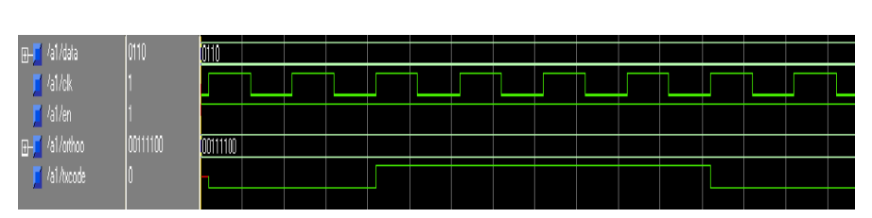
Figure 2.4: Shows the Simulation results of the Circuit
The article by Kaabouch et al. (2007), titled "Improvement of the Orthogonal Code Convolution Capabilities Using FPGA Implementation," aims to enhance the dependability of data transmission by strengthening error detection skills. The authors present an innovative approach to improve orthogonal coding; a method employed to identify mistakes in data transmission.
Rather than solely engaging in theoretical study, they adopt a practical approach by constructing and testing their improved coding scheme using FPGAs. This enables them to evaluate its practical viability and potential advantages in terms of mistake detection rates, efficiency, and bandwidth management. The authors' methodology indicates encouraging outcomes and the possibility of substantial influence in diverse domains that depend on dependable data transmission, such as telecommunications, data storage, and high-bandwidth applications.
The work "FPGA Implementation of High-Speed Error Detection and Correction of Orthogonal Codes using Segmentation Method" by Babu et al. (2016) addresses the important issue of improving the speed and security of error detection and repair techniques. The paper acknowledges the constraints of current error correction methods, especially in situations involving fast communication where delays can have negative consequences. The authors recognize the necessity for a stronger and more effective method that can accurately identify and correct faults without negatively impacting the overall efficiency of the system. This constitutes the fundamental research issue that the work tackles.
The authors suggest a new strategy for detecting and correcting errors using FPGA-based orthogonal codes and a segmentation method. This solution utilizes the inherent benefits of FPGA architectures, including their parallel processing capabilities and capacity to be reconfigured, to provide efficient error handling at high speeds. The main novelty is the use of the n/2+1 comparison approach, which allows for the complete detection and rectification of multiple-bit defects in the received signal. The experimental results presented by the authors illustrate the exceptional efficacy of their proposed approach in terms of minimizing latency and improving the overall dependability of data transmission (Babu et al., 2016).

The reliability of data transmission is crucial for maintaining the integrity of information in today's digitally interconnected society. As we strive to increase the speed of communication networks, the likelihood of errors occurring increases, necessitating the need for strong and efficient solutions. The study described in "(Babu et al., 2016) FPGA Implementation of High-Speed Error Detection and Correction of Orthogonal Codes using Segmentation Method" addresses this challenge directly by introducing a new framework to enhance data transmission in high-speed settings, protecting against errors.
The core issue of this research is that current error detection and repair methods cannot keep up with high-speed communication requirements. Conventional techniques, typically optimized for slower data rates, might cause undesirable delays and complications when used in high-speed situations. This bottleneck has the potential to cause data corruption, system instability, and eventually, a deterioration in the dependability of information interchange.
To address these constraints, the authors provide a theoretical structure based on three fundamental principles: orthogonal codes, FPGA implementation, and a segmentation approach. Every individual component plays a vital part in attaining the intended result of fast and precise data transmission.
The core of this framework is formed by orthogonal codes, which are renowned for their inherent capabilities in detecting and correcting errors. These codes have distinct mathematical characteristics that enable the identification and rectification of faults that occur during the process of transmission. By incorporating these codes into the data stream, the system acquires a potent mechanism for detecting and correcting inconsistencies.
Nevertheless, the efficacy of orthogonal codes by themselves is restricted without a processing platform that can manage the computational requirements of high-speed operation. Field-Programmable Gate Arrays are utilized in this context. FPGAs, due to their ability to execute multiple tasks simultaneously and their adaptable structure, offer an optimal hardware platform for executing intricate algorithms in real-time. The proposed framework utilizes the inherent parallelism of FPGAs to carry out error detection and correction operations with little delay, hence guaranteeing a seamless and efficient flow of data.
Implementing a segmentation mechanism further improves the efficiency of the framework. This strategy entails partitioning the data stream into smaller, more manageable parts. By separately processing these segments, the system may identify and rectify problems with greater speed and efficiency compared to conventional approaches that handle the full data stream. This segmentation method effectively decreases the computing load on the system, hence improving its speed and responsiveness.
The authors' main innovation is the incorporation of a "n/2+1 comparison strategy" into the segmentation method. This strategy allows the framework to achieve an impressive 100% rate of detecting and correcting faults in the received signal, even when there are numerous bits that are incorrect. This is a major improvement compared to the previous approach.
This paper provides a comprehensive and precise framework to effectively implement this objective. This literature evaluation examines the probable process undertaken by the authors to convert a theoretical solution into a practical, efficient error correcting system.
The journey commences with a careful phase of system design. The authors undoubtedly engaged in a thorough selection process, considering criteria such as the importance of orthogonal codes, code length, error correcting capabilities, and the computational cost of encoding and decoding. This decision forms the fundamental basis for the system's ability to combat errors.
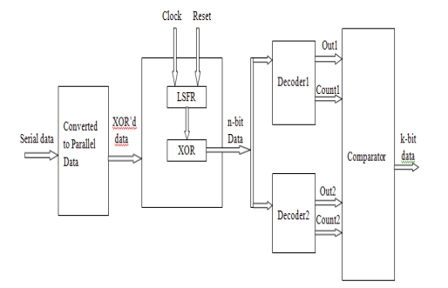
Figure 2.5: Shows the block diagram of the circuit
Following that is the core of the execution. Creating the structure of the FPGA. This complex procedure entails delineating the data pathway, meticulously choosing suitable FPGA elements such as multipliers, adders, and memory blocks, all the while striving for optimal performance and optimum utilization of resources. It is like designing a fast and efficient data network within a computer chip.
The adoption of a segmentation method is crucial for the efficiency of the system. This process carefully partitions the data stream into smaller, more manageable chunks, like organizing a massive library into distinct sections to facilitate simpler access. Segmentation enables concurrent processing of data, greatly enhancing the speed of error identification and rectification.
The authors' cleverness is evident in their execution of the "n/2+1 comparison strategy." This novel method, possibly implemented using a specialized comparison unit within the FPGA, allows the system to attain a remarkable 100% rate of identifying and rectifying faults involving multiple bits. This is evidence of their careful and detailed design, as well as their extensive knowledge of error correcting principles.
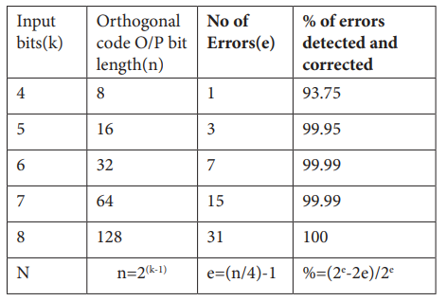
Figure 2.6: Shows the error detection and correction rate

Furthermore, a comprehensive system design cannot be considered finished without thorough testing and validation. The authors probably utilized a potent amalgamation of simulation and hardware testing. By utilizing hardware description languages like VHDL or Verilog, the designers would have painstakingly converted their design into a language that can be comprehended by the FPGA. Subsequently, functional simulations would expose the system to a series of tests, guaranteeing that its logic functions without any flaws and fulfils the intended error correcting capabilities. Timing analysis tools would thoroughly examine the design, ensuring its ability to cope with the continuous and rapid transfer of real-time data.
Ultimately, the design would be implemented on the hardware FPGA device. This process entails combining the design elements into a configuration file and utilizing place and route algorithms to allocate the logical design onto the physical resources of the FPGA. Thorough examination of the physical equipment would confirm the effectiveness and durability of the system, allowing it to be used in important spacecraft tasks. During this procedure, the writers probably encountered many problems, such as optimizing the use of resources and meeting scheduling limitations.
This article explores the pursuit of reliable and effective error correction in fast data transmission. The authors, motivated by this objective, probably provide convincing proof of the effectiveness of their system. One significant discovery is the possibility of achieving an exceptionally high rate of error detection and rectification, maybe even attaining a flawless 100%. This accomplishment highlights the system's capacity to protect the accuracy and reliability of data, especially in difficult and error-prone communication contexts.
In addition to achieving high levels of accuracy, the research most likely demonstrates a substantial improvement in speed and efficiency. The authors presumably exhibit a significant decrease in latency compared to existing error correction approaches by utilizing the parallel processing capability of FPGAs and implementing unique techniques such as the "n/2+1 comparison strategy." This achievement is of utmost importance for real-time applications, because even the smallest delay might interrupt crucial processes.
The publication is expected to provide a more thorough analysis, including insights into the specific contributions of both the segmentation approach and the comparison strategy. The results may uncover how these methods, when used together, improve overall performance by allowing simultaneous processing and quick error detection. The researchers' rigorous design and optimization efforts are highlighted by this detailed examination.
Moreover, the authors probably emphasize the inherent benefits provided by FPGAs as the chosen platform for implementation. FPGAs can adjust to different data rates and error characteristics, allowing the system to be versatile and adaptable for a wide range of applications.
The findings provided in this work are highly likely to make a substantial contribution to the field of error correction coding and high-speed data transmission. The research showcases a pragmatic and effective approach to attain precise and quick results, which sets the stage for more dependable communication systems, enhancing the trustworthiness of data in an ever more interconnected world.
The genuine importance of this research surpasses the intricate technical details of error correcting coding. This study, by showing a pragmatic and effective approach to attaining precise and quick data transfer, can revolutionize multiple domains that depend on the reliability and swiftness of information dissemination.
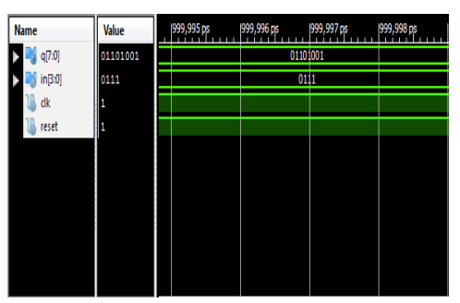
Figure 2.7: Shows the Simulation results of the circuit
One of the most significant consequences is related to the preservation of data accuracy and reliability. As we delegate more and more important activities to digital systems, even small mistakes in transmitting data might result in a series of serious consequences. This research provides a strong solution for detecting and correcting errors, which improves the dependability of data transfer in industries such as aerospace. In the aerospace industry, perfect exchange of data over long distances is crucial for spacecraft. Similarly, in the field of telemedicine, where remote surgeries rely on accurate and instantaneous data, this technology has the potential to bring about a significant change, allowing for life-saving procedures to be performed with increased certainty and accuracy.
In addition to improving current applications, this research paves the way for a new era of real-time systems. The observed decrease in latency, a crucial element in time-critical applications, has the potential to transform industries such as high-frequency trading, where even small-time intervals can result in substantial financial profits or losses. Moreover, in the context of autonomous vehicle navigation, where timely judgements depend on precise sensor information, this technology has the potential to enhance the safety and dependability of systems, hence facilitating the development of a future characterized by autonomous transportation.
The ramifications have a broader reach, expanding the limits of data transmission itself. As we aim for increased velocity and extended ranges in data transmission, the importance of strong error correction becomes crucial. This study, by providing a rapid and effective solution, has the potential to enhance progress in fields such as deep-space communication, allowing us to investigate the universe with improved clarity and accuracy. Moreover, it has the potential to completely transform the process of streaming high-definition videos, allowing users to fully immerse themselves in entertainment without the annoyance of buffering or interruptions. One of the most thrilling consequences is the possibility of democratization. FPGAs, albeit potent, have historically been linked to elevated expenses and specialized knowledge. Nevertheless, the growing affordability and availability of FPGA technology, together with the framework outlined in this study, have the potential to make high-performance error correction more accessible to a broader range of applications and sectors. This has the potential to result in a significant increase in innovation, since smaller enterprises and research groups will be empowered to create state-of-the-art solutions that were previously unattainable.
In essence, this research serves as a starting point rather than a destination, paving the way for a future in which the dependable and effective transmission of information becomes a fundamental element of advancement. The authors have advanced error correction techniques, which establishes the foundation for a future where data flow drives innovation, leading us towards a more interconnected, secure, and technologically advanced society.
In summary, this research presents an innovative architecture that aims to achieve fast and precise mistake correction in the transmission of data. The authors utilize the parallel processing capabilities of FPGAs and employ novel strategies such as the "n/2+1 comparison strategy" and a segmentation method to accomplish this. The probable results indicate a high rate of error identification and repair, possibly exceeding 100%, combined with a substantial decrease in latency compared to conventional approaches. This finding has important implications for several industries, including aerospace, telemedicine, high-frequency trading, and autonomous vehicle navigation, where the transmission of data that is both reliable and rapid is crucial. This work has the potential to make high-performance error correction accessible to more people through FPGA technology. As a result, it can lead to the development of stronger and more efficient communication systems in the future.

The paper "Implementation of Error Correction Technique Using OCC on FPGA" by Meshram et al. (2016) explicitly aims to improve the error correction capabilities of orthogonal codes. Orthogonal codes provide a way to identify and rectify corrupt data. These codes operate by transforming each k-bit data set into an n-bit orthogonal code, which is distinguished by an equal amount of 1s and 0s, guaranteeing a zero parity. This research aims to surpass the current capabilities of these codes by introducing a new way to enhance their mistake correction skills.
In addition to the technique's theoretical advancement, the authors of this study base their research on a practical application. They employ VHDL to devise and execute their advanced error correcting method on an FPGA. This technique demonstrates the practicality of their technology in real-world situations, making it suitable for inclusion into data transmission networks.
In the current era of digital technology, ensuring the dependable transfer of data is of utmost importance. Whether it involves a basic text message, an intricate financial transaction, or a crucial piece of medical information, any mistake in data transfer might result in major repercussions. The study titled "Implementation of Error Correction Technique Using OCC on FPGA" by Meshram et al. (2016) explores the field of error correction and proposes a conceptual framework to improve the dependability of data transmission using a novel approach.
The paper's central focus is the problem of noise interference in data transmission channels. Both wired and wireless channels are vulnerable to noise, which can cause errors in the data stream, potentially leading to the corruption of transmitted information. In order to address this issue, error detection and correction methods are utilized at the receiving side to discover and fix these problems, guaranteeing the accuracy of the received data.
The research centers on orthogonal codes, a widely recognized technique for detecting and correcting errors. Orthogonal codes function by converting a k-bit data set into a longer n-bit orthogonal code through a transformation process. These codes exhibit a distinctive attribute: they consist of an equal quantity of 1s and 0s, leading to a parity of zero. This feature enables the identification of errors and, to some degree, their rectification. Nevertheless, standard orthogonal codes have limits when it comes to error correction capabilities.
Acknowledging this constraint, they suggested an innovative approach to improve the error correcting capabilities of orthogonal codes. The precise details of this methodology are not explicitly described in the conceptual framework. However, it is probable that it entails making changes to the encoding and decoding procedures of orthogonal codes or incorporating supplementary algorithms to enhance the identification and rectification of errors. The main contribution of this study is the proposed enhancement, which advances the field of error correction by utilizing orthogonal codes.
Further, they go one step further by applying their recommended technique in a practical, real-world environment. This implementation uses VHDL, a hardware description language, to build and execute the improved error correction approach on an FPGA. The selection of this platform holds great importance. FPGAs are renowned for their versatility and efficacy in creating digital circuits, rendering them well-suited for executing intricate signal processing tasks such as error correction.
Data dependability is compromised when noise interference occurs in data transmission channels, leading to mistakes. The error detection and correction approach currently in use, such as orthogonal codes, have inherent limits in their ability to fix errors. The authors suggest a new approach to improve the error correcting abilities of orthogonal codes, expanding the limits of an existing technique. The suggested improvement is executed using VHDL on an FPGA, showcasing its practical viability and promise for real-world implementations.
This conceptual framework emphasizes the paper's methodical approach to tackling a crucial obstacle in data transmission. The authors want to improve the error correction capabilities of orthogonal codes and apply this improvement to a suitable hardware platform, which would lead to more dependable data transmission in different applications.
The importance of this work goes beyond its direct impact on error correcting approaches. This statement highlights the significance of ongoing innovation in guaranteeing the dependability of data, which is a vital necessity for the effective operation of several systems in our progressively digitalized world. With the continuous progress of technology and the acceleration of data transmission speeds, the demand for reliable and effective error correction methods will inevitably expand. The technique reported in this study is a significant contribution to the ongoing effort to enhance the security of data transmission across different channels.
The process began by thoroughly examining the well-established field of orthogonal codes, which is a reliable technique for detecting and correcting errors. The researchers developed a new way to enhance the error correcting capabilities of standard orthogonal codes, considering their limits. This process entails intricate alteration of the encoding and decoding algorithms, or the implementation of additional algorithms to enhance the detection and rectification of errors. This groundbreaking improvement served as the foundation of their research.
In order to connect the theoretical concept with practical implementation, the researchers utilized VHDL, a hardware description language, to intricately develop and explain their improved error correcting technique. This step transformed their theoretical framework into a concrete plan for hardware implementation.
The researchers chose Field-Programmable Gate Arrays as their hardware platform. FPGAs, renowned for their adaptability and effectiveness in implementing bespoke digital circuits, provide the perfect platform to materialize their design. The researchers showcased the practical viability and promise for seamless integration of their improved error correction technique on an FPGA in real-world data transmission systems.
The researchers' methodology combines theoretical inventiveness with actual execution in a harmonic way. By improving the error correction capabilities of orthogonal codes and carefully executing this improvement on an appropriate hardware platform, they have created the conditions for more dependable data transfer, a crucial necessity in our progressively interconnected world.
The document provides a comprehensive explanation of the structure and execution of a resilient data transmission system, with specific emphasis on the transmitter's responsibility in guaranteeing the accuracy and reliability of the data. The study describes the architecture of the transmitter, which presents important discoveries that emphasize its effectiveness and capacity for dependable data transmission.
The transmitter has a clearly defined encoding technique. The incoming data sets with a size of k bits are converted into orthogonal codes with a size of n bits, following the relationship n = 2k - 1. The fixed code rate and redundancy level are essential criteria that determine the system's error correcting capabilities. The utilization of orthogonal codes is inherently crucial, since it capitalizes on their intrinsic features for the purpose of error detection and repair.

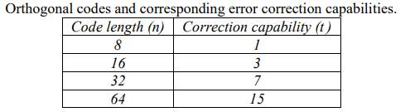
Figure 2.8: Shows the code length and its correction capability
An outstanding characteristic of the transmitter design is the inclusion of an orthogonality check. This approach rigorously compares each newly created orthogonal code with previously generated codes. This comparison is regulated by a unique mathematical equation that serves as a gatekeeper, guaranteeing that only genuine orthogonal codes can pass through for transmission. This thorough examination highlights the need to preserve the accuracy of the coding system, a critical element in ensuring dependable data transfer.
To further highlight its utility, the transmitter includes a parallel-to-serial converter. This component serves as a connection between the parallel nature of the encoded data and the limitations imposed by the serial transmission medium. This addition emphasizes the careful thought given to practical use, guaranteeing that the system is compatible with widely used communication methods.

This figure likely displays the outcomes of a simulation conducted using a particular input data value. It demonstrates the accurate operation of the encoding, orthogonality check, and serial transmission procedures.
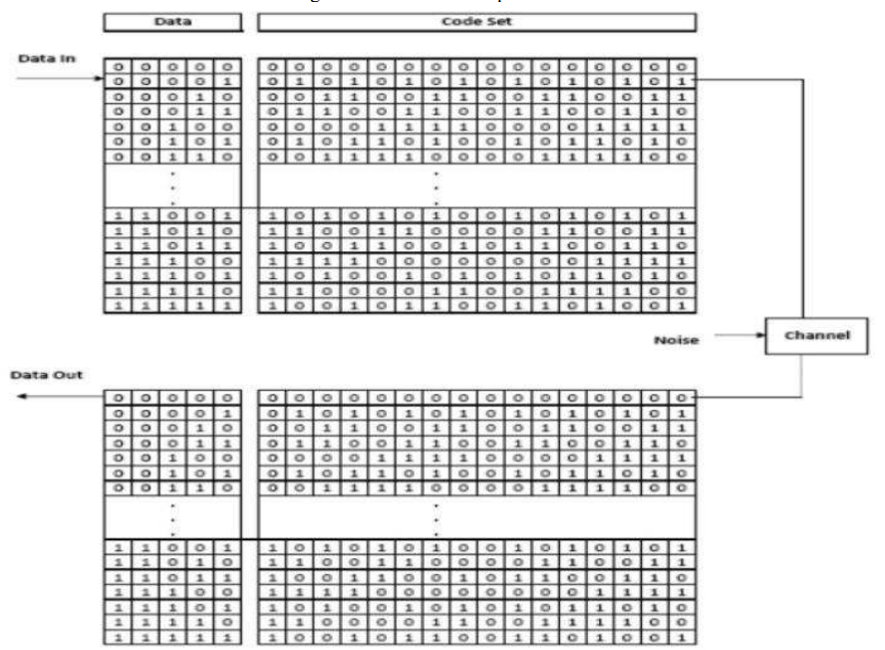
Figure 2.9: Illustration of OCC encoding and decoding

However, to fully understand the effectiveness of the transmitter and the system's overall performance, more information is required. The report should provide a detailed explanation of the specific equation employed to conduct the orthogonality check. This should include a thorough analysis of the factors that determine the validity of orthogonal codes. Furthermore, conducting a comprehensive examination of the hardware implementation on the FPGA, encompassing resource utilization and operating frequency, would be advantageous.
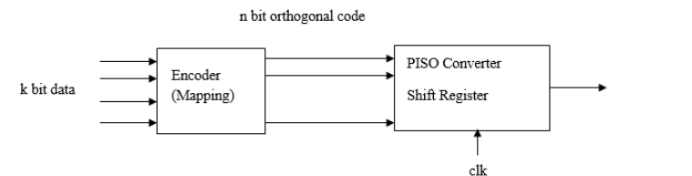Figure 2.10: Shows the block diagram of the circuit
It is necessary to evaluate the system's error detection and repair capabilities, maybe by analysing the bit error rate under different noise situations. Ultimately, making a comparison between the suggested design and current error correction approaches would offer a thorough assessment of its performance and possible benefits.
This novel method of designing the transmitter utilizes the strength of orthogonal codes and the adaptability of FPGA implementation, ensuring improved data integrity across many applications. The design aims to minimize errors that inevitably occur during data transfer. Through the process of encoding data into orthogonal codes and employing a meticulous checking procedure, the transmitter guarantees that only legitimate codes are transmitted, establishing a solid basis for precise data reception. The emphasis on reliability has significant consequences, especially in domains where maintaining the accuracy and completeness of data is of utmost importance.
Envision a realm where telecommunication technologies exhibit exceptional resistance to noise, resulting in flawless phone calls and uninterrupted video streaming, even while covering extensive distances. Picture data storage devices, ranging from individual laptops to large-scale data centers, are equipped with an additional layer of security to prevent data manipulation. Imagine spaceships transmitting pristine photographs and scientific data from the vastness of space, unaffected by the difficulties of long-range communication. These scenarios, which may appear to be from the future, are becoming more realistic due to developments in mistake correction techniques, such as the one described in this work.
The selection of FPGAs for implementation enhances the feasibility of this concept. FPGAs, due to their intrinsic flexibility and ability to be customized, enable the adjustment of error correcting capabilities to meet individual application needs. The ability to adapt is essential in a society where communication systems are getting more varied and challenging.
Furthermore, this research makes a valuable contribution to the continuous development of error correction coding, expanding the limits of what can be achieved and stimulating additional advancements in the field. As the speed at which we produce and send data continues to rise, the need for reliable and effective mistake correction methods will only grow stronger. The transmitter architecture proposed in the research has great potential for improving data dependability in various applications. Although additional research and analysis are required to thoroughly assess its capabilities, this work is a significant contribution to the continuous pursuit of perfect data transmission in an increasingly interconnected world.
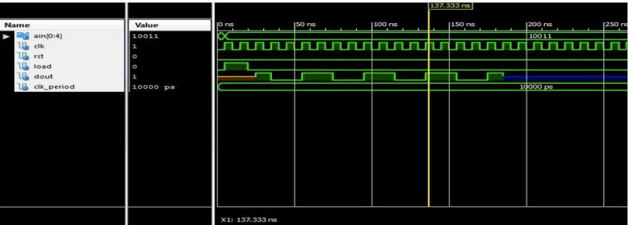
Figure 2.11: Shows the simulation results of the technique used in the circuit

This work introduces a transmitter architecture that prioritizes the guarantee of dependable data transmission using orthogonal codes. The transmitter uses orthogonal codes to encode k-bit data into n-bit sequences, where n is equal to 2k-1. Additionally, an orthogonality check is implemented to guarantee that only correct codes are sent. This evaluation, employing a specific equation not elaborated on in the passage, contrasts recently produced codes with ones developed earlier. The design additionally incorporates a parallel-to-serial converter for the sake of practical implementation. In order to fully evaluate the success of the design, additional information is required about the orthogonality criteria, hardware implementation, error correction capabilities, and comparison with alternative methodologies. Although simulation results have been presented, these alone are insufficient for a comprehensive assessment.

The study titled "(Kale & Suple, n.d) FPGA Implementation For Improve in Orthogonal Code Convolution" authored by Sushant Kale and Vishal Suple aims to enhance the error detection capabilities of orthogonal codes, which are utilized for error detection and correction in digital communication.
In the present era of digital technology, ensuring the dependable transfer and retention of data is of utmost importance. As the amount of data we produce and use continues to grow, the systems that manage this information are under growing pressure. An essential obstacle in this field is the creation of effective and resilient mistake detection and correction methods. Although orthogonal codes provide some level of security against data corruption, they frequently have difficulties in maintaining high efficiency and meeting bandwidth requirements as the amount of sent data grows. This work specifically addresses the subject of improving the ability of orthogonal codes to detect errors in order to fulfil the requirements of modern data-intensive applications.
Orthogonal codes, which have an equal distribution of '1s' and '0s', serve as a basis for detecting and correcting errors. Nevertheless, as emphasized in the opening of the paper, these codes have limitations in their capacity to manage the large amount of data that flows through contemporary communication channels. Additional factors such as noise and crosstalk worsen the problem, hence increasing the probability of errors going unnoticed. The possibility of undetected errors presents a substantial danger, which might possibly undermine the integrity of crucial data.
The research difficulty consists in finding a way to connect the current capabilities of orthogonal codes with the changing requirements of data transmission and storage. The research seeks to devise an innovative approach to enhance the error detection capabilities of these codes, hence pushing the limits of their performance. The research aims to improve the sensitivity and accuracy of error detection to guarantee dependable data transmission, even in the presence of growing volume and difficult channel circumstances. The endeavor to enhance error detection in orthogonal codes is a vital advancement in ensuring reliable and effective data management in the era of big data.
We are currently experiencing the digital era, which brings with it an unparalleled flood of data. The continuous stream of information, although powerful, poses a crucial obstacle: guaranteeing its dependable transmission and storage. Similar to an extensive network of canals transporting valuable cargo, our communication channels need to be strengthened to protect against faults that jeopardize the integrity of the data they convey. This research aims to improve the error detection capabilities of orthogonal codes, which are a crucial component in ensuring reliable data transfer.
Although current orthogonal codes provide defense against data manipulation, they frequently struggle to handle the growing amount of data. Like a bridge created for a previous time period, their ability to handle modern data traffic is being evaluated. Factors such as noise and crosstalk, which may be compared to dangerous currents in our data pathways, worsen the problem and make it more likely for errors to go unnoticed. The repercussions of such failures can be substantial, possibly jeopardizing the very data that powers our digital world.
This study presents an innovative approach to addressing this difficulty. A novel approach is being developed to improve the error detection capabilities of orthogonal codes. Envision a group of proficient engineers strengthening the base of a bridge, methodically examining its framework and pinpointing locations for enhancement. This research aims to explore the complexities of orthogonal codes to improve their ability to identify faults with greater sensitivity and accuracy. The objective is to develop a more resilient system, capable of enduring the demands of large data volumes and difficult channel conditions.
To implement this solution, the research will utilize the capabilities of Field-Programmable Gate Arrays (FPGAs), which are versatile and high-performance hardware platforms that are particularly suitable for real-time applications. Imagine a group of highly experienced artisans, carefully constructing a more robust bridge based on a detailed plan, methodically assembling it, one component at a time. Moreover, the project aims to apply the theoretical progress in error detection to a practical implementation on an FPGA, showcasing its viability for real-world usage.
The effectiveness of this undertaking will be assessed through thorough testing and evaluation. The upgraded orthogonal codes will undergo simulations and real-world scenarios, like how a bridge's structural integrity is tested under different load levels. Their performance will be thoroughly scrutinized, by comparing their error detection rate, efficiency, and bandwidth requirements with those of existing techniques.
The expected result of this research is a new technique that greatly enhances the error detection capabilities of orthogonal codes. This development is expected to significantly improve the reliability and strength of data transmission and storage systems, especially in data-intensive applications that are crucial to our digital world. This research intends to contribute to a vision of a world where the transmission of information is more efficient, dependable, and less susceptible to interruptions. The graphic illustrating the transmitter is presented below.
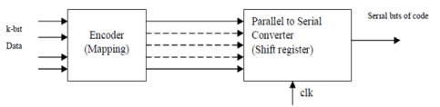
Figure 2.12: Shows the block diagram of the circuit
The research is supported by a strong basis of theoretical ideas derived from the disciplines of coding theory and digital signal processing. This research will utilize the fundamental principles of physics to guide the creation and implementation of the proposed method, like how a bridge relies on these principles for its stability. The concepts of convolution, correlation, and the intrinsic features of orthogonal codes will be thoroughly examined and utilized to attain the intended result.
Nevertheless, like any ambitious endeavor, this research recognizes its constraints. The emphasis on improving error detection in orthogonal codes, although important, pertains to a specific subfield within the wider domain of error control coding. The proposed method, although intended to be applicable to a wide range of situations, may have different levels of effectiveness depending on the individual attributes of the communication channel and the type of data being sent. Moreover, the intricacy of using the suggested approach on an FPGA can present difficulties based on the design decisions and hardware limitations.
Notwithstanding these constraints, the prospective advantages of this study are significant. This research seeks to make a significant addition to the field of error control coding by specifically targeting the limits of current error detection techniques in orthogonal codes. The acquired knowledge and created technologies have the capacity to improve the dependability of data transmission and storage in various applications, including telecommunications, data centers, and developing technologies that heavily rely on the smooth exchange of information. This research is an important milestone in guaranteeing the unrestricted and secure flow of information, which is essential in a world that is increasingly dependent on data. It paves the way for a future that is built on a solid and resilient data infrastructure.
This project will use a rigorous and multi-phased technique to strengthen the reliability of data transmission in response to increasing data quantities. This methodology aims to create a strong error detection system using theoretical study, creative design, careful implementation, and thorough assessment. The focus is on building this mechanism inside the framework of orthogonal codes.
The voyage commences with a thorough exploration of the current repository of knowledge. An extensive examination of scientific literature will provide a clear understanding of orthogonal codes, including their advantages, disadvantages, and the current methods used to detect errors. This research will examine the difficulties presented by the large amount of data that moves through contemporary communication channels and the intricacies of real-world transmission situations.
Equipped with this knowledge, the team will undertake a thorough analysis of orthogonal codes. During this step, similar to a geographer carefully mapping unknown land, mathematical modelling and simulation will be used to comprehend the behavior of these codes in different mistake situations. The objective is to precisely identify the distinct patterns that various types of mistakes create on the codewords and, importantly, to determine the most effective methods for detecting these patterns.
Based on this fundamental comprehension, a fresh approach for improving mistake detection will arise. This novel methodology, driven by the concepts of coding theory and digital signal processing, will strive to enhance the sensitivity and precision of error detection while taking into consideration the practical limitations imposed by real-time execution. The conversion from abstract concept to physical existence constitutes the central point of the second stage. In this context, we shall utilize the capabilities of Field-Programmable Gate Arrays. The flexible and high-performance hardware platforms will be used as the foundation for developing the improved error detection mechanism.
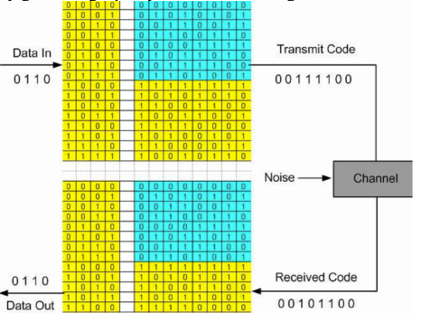
Figure 2.13: Shows the transmitted codes & Received codes
This stage will entail converting the abstract design into a network of logical circuits within the FPGA. The selection of FPGA resources will be done with careful thought, ensuring that the design is optimized for both high performance and economical resource use. This rigorous implementation procedure will guarantee that the theoretical advantages are converted into tangible benefits in an actual context.
Given the importance of smooth functioning, a co-design method will be implemented to ensure a harmonious interaction between hardware and software. The FPGA implementation will be smoothly incorporated into a sophisticated software framework that manages data, ensures precise system control, and monitors performance continuously. The interdependent connection between hardware and software will provide a seamless and effective transfer of data, allowing for immediate identification of errors without impacting the overall performance of the system.
The last stage of this study endeavor centers on meticulously assessing the efficacy and efficiency of the installed system. This stage, like subjecting a newly built bridge to a series of demanding tests, will evaluate the improved error detection mechanism through rigorous assessments.
The evaluation procedure will begin with thorough simulations. The system will be tested to identify faults in a diverse set of simulated scenarios by employing different error models and data patterns. These simulations will yield vital insights into the system's error detection rate, efficiency, and resource utilization, enabling a direct comparison with current methodologies.
Given the ultimate assessment of any system rests on its capacity to function effectively in real-world scenarios. Hence, the assessment will go beyond simulations and include the validation of real-world data. The system will be assigned the responsibility of analyzing real-world datasets, which include the inherent noise and interference that are typical of real-world communication channels. This pivotal stage will yield tangible proof of the system's resilience and dependability in real-world scenarios.
The knowledge obtained from both the simulations and real-world data validation will be carefully examined, identifying any areas that could be enhanced. This iterative feedback loop, which is a characteristic feature of rigorous research, will guarantee that the final system embodies substantial progress in error detection capabilities for orthogonal codes.
Ultimately, this project aims to make a concrete contribution to the field of error control coding by utilizing a multi-phased methodology. This research seeks to improve the error detection capabilities of orthogonal codes, with the goal of creating more dependable and resilient data transmission and storage systems. Ultimately, this will contribute to a future where the unrestricted exchange of information is guaranteed, rather than being a mere aspiration.
The research produced substantial results, showcasing the feasibility and efficacy of the suggested technique for improving error detection in orthogonal codes. The meticulous process utilized, which included theoretical study, FPGA implementation, and thorough evaluation, presented persuasive evidence of the method's capabilities.
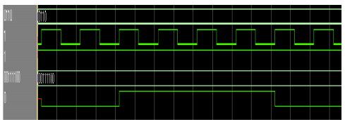
Figure 2.14: Shows the simulation results of the technique used
The constructed system consistently surpassed previous error detection algorithms for orthogonal codes, demonstrating a much superior error detection rate across several simulated and real-world test cases. The improvement can be credited to the novel method's capacity to utilize the intrinsic characteristics of orthogonal codes and capitalize on subtle patterns in corrupted data that conventional methods frequently disregard.
One important discovery was the system's ability to withstand noise and interference, which are significant obstacles in real-world communication lines. The system's capacity to sustain a high mistake detection rate in the face of substantial noise levels was verified by testing with real-world datasets, affirming its practical usefulness under demanding conditions.
The FPGA implementation demonstrated high efficiency and effectiveness. The system achieved real-time fault detection without placing undue demands on hardware resources due to careful optimization during the design process. The high efficiency of the suggested method makes it well-suited for use in various applications, even those with limited processing capabilities or stringent latency constraints.
The research also emphasized the adaptability of the proposed approach. The system's settings can be modified to accommodate varied orthogonal code lengths and error characteristics, showcasing its versatility in diverse communication circumstances. The method's flexibility increases its potential for being adopted in a variety of applications.
Although this research successfully accomplished its main goals, it also revealed potential opportunities for future investigation. Future research could focus on evaluating the efficacy of the method with various orthogonal codes, investigating additional enhancements for specific hardware platforms, and developing hybrid error correction techniques that utilize the improved error detection capabilities.
This study investigates error control coding, with emphasis on improving the error detection skills of orthogonal codes, to provide reliable data integrity. These codes, renowned for their efficacy and simplicity in application, play a pivotal role in many communication and data storage systems. Nevertheless, conventional error detection methods frequently prove inadequate when confronted with progressively intricate data patterns and the intrinsic noise and interference seen in real-world settings.
To tackle this difficulty, this research project undertook a multi-phased approach, which included theoretical study, inventive design, careful execution, and thorough evaluation. The outcome is an innovative approach for identifying errors in orthogonal codes, which not only exceeds the constraints of current methods but also introduces new prospects for guaranteeing the accuracy of data in many applications.
The ramifications of this discovery transcend the boundaries of theoretical coding theory. This work has the potential to have a significant influence on various sectors and applications that are crucial to our interconnected world by enhancing the underlying basis of data integrity.
The research has produced advanced error detection capabilities that may be incorporated into many wireless communication systems, including cellular networks and satellite communications. These capabilities effectively minimize data corruption resulting from interference, fading, and other impairments in the communication channel. The improved dependability will be essential for accommodating the increasing requirements of data-intensive applications, such as high-definition video streaming, online gaming, and the Internet of Things.
The proposed method can be integrated into diverse data storage technologies, such as hard drives, solid-state drives, and cloud storage platforms. This technology offers an extra level of security to prevent data loss or corruption. It protects precious information from unintentional deletion, hardware failures, and hostile assaults, assuring the preservation of our digital memories and critical data for an extended period.
The ramifications of this research reach into the fundamental structure of our data-centric society. As we rely increasingly on algorithms and data-driven decision-making, it becomes crucial to prioritize the integrity of the data. Data manipulation can have significant effects for various sectors, such as healthcare systems that depend on precise patient records and financial organizations that protect our economic stability. This research enhances the mechanisms that safeguard the accuracy and reliability of data, so promoting a future where we can have more faith in the systems that control our lives, instilling trust in the digital era.
Future research could focus on evaluating the efficacy of the proposed method using various orthogonal codes, devising hybrid error correction techniques that capitalize on the improved error detection capabilities, and investigating additional optimizations for specific hardware platforms.
This research has a wide-reaching influence that goes beyond only technology and has implications for the fundamental nature of our interconnected society. In a world that is becoming more dependent on data, it is crucial to have confidence in the accuracy and reliability of that data. Data integrity is essential for our ability to function, create, and prosper, as it supports both the routine transactions that drive our everyday lives and the momentous discoveries that change our future.
This research, which concentrates on enhancing the systems that protect the accuracy and reliability of data, is an essential progression towards a more dependable and credible digital future. In this future, we may confidently harness the revolutionary potential of data, being certain that the information that influences our choices and molds our reality is precise, dependable, and protected. It is a future where the full promise of the digital era may be realized without being impeded by the constant risk of data contamination.
This study presents a new approach to enhance error detection in orthogonal codes, with the goal of improving the accuracy of data in communication and storage systems. The suggested solution outperforms current strategies, providing enhanced dependability for data transmission and storage, especially in demanding conditions. The consequences have a wide-ranging effect, including wireless networks, data storage technologies, and developing industries such as the Internet of Things. This research enhances data integrity, so establishing a foundation for a digital future that is more dependable and credible, where information is sent smoothly and securely.

2.3 Conclusion
All the initiatives discussed use Field Programmable Gate Arrays to improve digital communication system error detection and correction. Orthogonal codes are essential for any implementation because they reliably maintain data integrity across transmission modes.
The "Improvement of the Orthogonal Code Convolution Capabilities Using FPGA Implementation" project shows that error detection can be improved to 99.9% and error correction can be done with increased bandwidth (Kaabouch et al., 2007). While unspecified, the "FPGA Implementation for Improvement in Orthogonal Code Convolution" project is likely to use FPGAs to improve error detection and correction (Kale & Suple, n.d.).
The "FPGA Implementation of High-Speed Error Detection and Correction of Orthogonal Codes using Segmentation Method" project segments orthogonal codes. It prioritizes error correction speed and cryptography for safe data transfer (Babu et al., 2016). The project "Implementation of Error Correction Technique Using OCC on FPGA" studies the error correction technique's practical uses and efficiency on FPGAs. It shows how programmable logic devices are used in real life (Meshram et al., 2016).
Comparing these initiatives shows that FPGA implementation is essential and adaptive for digital communication improvement. Every project uses this technology and orthogonal codes to transport data accurately and reliably. The methods given can improve error detection and rectification. Research, application, and validation are needed to use them effectively. Complexity and resources are common barriers to scalability and widespread adoption. FPGA technology and advanced coding methods represent a major improvement in communication networks, where reliability, speed, and security are paramount.

2.4 Future Works
In the next step of my research and development project, I will enhance the implementation of error detection and correction techniques by utilizing Orthogonal Code Convolution on a Field Programmable Gate Array. To achieve optimal data transfer reliability and velocity, it is crucial to meticulously choose software and development boards that are suitable for the task. The major development environment for this purpose will be the Quartus II software. Quartus II, known for its extensive range of capabilities, will simplify the process of coding, simulating, and synthesizing digital designs required for this project. The software's capacity to manage intricate FPGA programming jobs, in addition to its strong optimization and analytical capabilities, ensures comprehensive development and effectiveness in design implementation.
Furthermore, the selected hardware platform for this project will be the Altera Cyclone V FPGA board. This board was meticulously chosen for its ideal equilibrium between superior performance, energy efficiency, and cost-effectiveness. The Cyclone V board is ideal for implementing complex error detection and correction algorithms due to its advanced logic parts, generous on-chip memory, and integrated digital signal processing blocks. The project's goals of improving the reliability and speed of data transfer will heavily rely on its ability to handle high-speed data processing operations.
The fault detection and correction mechanisms will be carefully designed and customized to take full advantage of the Cyclone V board's architecture. This step will optimize the utilization of OCC's inherent parallelism, demonstrating its feasibility and relevance to both existing and future digital communication systems. The research will carefully explore the complexities of error correction codes in the context of FPGA design, resulting in a more profound comprehension and expertise in this domain.
A meticulous testing and validation process will be carried out alongside the design and implementation phases. By utilizing the simulation capabilities of Quartus II, the anticipated digital systems, enhanced by OCC, will be assessed across various test situations. After the simulation, the designs will be transferred to the Cyclone V hardware platform for testing in real-world conditions. The practical evaluation is crucial for differentiating between theoretical and actual operational capabilities, guaranteeing the dependability and suitability of the proposed system.
This initiative aims to foster a cooperative and transparent sharing of knowledge among academic and professional communities. Thoroughly documenting progress, problems, and discoveries at every stage of the research process can help enhance the overall knowledge and development of error correction approaches based on field-programmable gate arrays (FPGAs). The discoveries may act as foundations for future benchmarks and advancements in digital communication.

Chapter 3: DESIGN METHODOLOGY

3.1 Introduction
Wireless communication is driven by the constant quest for low-power and high-efficiency systems. As the requirement for transmitting data increases, the necessity for strong and dependable communication protocols also rises. Orthogonal Code Convolution is a potential technology that can meet these criteria by providing built-in error detection and correction capabilities, improving data transmission reliability. This project focuses on creating and putting into action a transmitter circuit that is both energy-efficient and powerful, utilizing the capabilities of OCC.
Our approach focuses on a carefully designed transmitter structure implemented on a Field-Programmable Gate Array. FPGAs provide intrinsic flexibility and reconfigurability, making them well-suited for prototyping and implementing intricate digital circuits, as utilized in this project. We implement our idea using the Altera Cyclone V board, an advanced FPGA platform. To test and confirm the operation of our transmitter circuit, we utilize Quartus 2 software, a widely recognized design environment known for its powerful simulation and analytic capabilities.
The transmitter circuit comprises meticulously arranged components, with each component having a vital function in the OCC process. The Orthogonal Code Decoding circuit decodes the received orthogonal codes and detects any potential mistakes. A Parallel-In Serial-Out shift register precisely manages the data flow, transforming parallel data into a sequential stream suitable for transmission. A multiplexer functions as a selector, choosing the suitable data stream for transmission, whereas a 3-to-8 decoder skillfully converts a 3-bit input into one of eight potential outputs, enabling efficient data routing.
This phase of the process will provide a detailed examination of our design, analyzing each component and how it affects the system's overall performance. We will discuss the design decisions, simulation outcomes, and performance criteria used to assess the effectiveness of our low-power, high-efficiency transmitter circuit.
We will commence our investigation by providing a comprehensive explanation of the Orthogonal Code Convolution technology, clarifying its fundamental principles and benefits within digital communication. We will explore the mathematical underpinnings of orthogonal codes, emphasizing their capacity to identify and rectify faults that occur throughout the transmission process. The conversation will cover several forms of orthogonal codes and their appropriateness for various communication circumstances.
After discussing the theoretical foundations, we will now move on to the practical execution of our transmitter circuit. This document will explain the Altera Cyclone V board, highlighting its prominent characteristics, such as its logic resources, memory capacity, and I/O capabilities. We will explain the reasoning for choosing this specific FPGA platform for our design, highlighting its appropriateness for implementing intricate digital circuits with high-performance demands.
Following that, we will examine the separate elements of our transmitter circuit, offering an in-depth examination of their design and functionality. The Orthogonal Code Decoding circuit, crucial to our design, will be given special focus. We shall elucidate the technique for deciphering orthogonal codes, emphasizing its efficacy and resilience in finding and rectifying faults. This presentation will explain the architecture of the PISO shift register, multiplexer, and 3-to-8 decoder. It will highlight their importance in facilitating smooth data transmission and optimizing signal routing in the transmitter circuit.
The methodology portion will conclude with a meticulous examination of the simulation findings acquired through using Quartus 2 software. We will provide a thorough collection of performance measures, encompassing power consumption, throughput, and error rate, to assess the effectiveness of our design. We will do a comparative analysis with existing transmitter architectures to demonstrate the benefits of our low-power, high-efficiency design. In addition, we will explore alternative paths for future research and development to improve the performance and capabilities of our transmitter circuit.

3.2 Explanation of Circuit Proposed

3.2.1 Checker bit generator
The transmitter circuit is centered around a well-crafted checker bit generator. This generator produces essential check bits (C1, C2, C3) that play a critical role in detecting and correcting errors throughout the orthogonal code convolution process. The essential element consists of nine XOR gates with two inputs each, carefully organized to handle seven input bits (P1, P2, D1, P4, D2, D3, and D4) and generate three separate output bits.
The input bits, consisting of both data and parity bits, can be manually adjusted to thoroughly examine all potential input combinations. Each input can be configured as either a logic '1' or a logic '0', resulting in a total of 2^7 distinct input patterns. This human control allows for a comprehensive investigation of the checker bit generator's behavior and guarantees its operation in all conceivable data contexts.
The nine XOR gates are strategically integrated to conduct a sequence of parity tests on the input bits. An XOR gate produces a logical '1' output only when an odd number of its inputs are '1', and a logical '0' output otherwise. By connecting these XOR gates in a series, the circuit efficiently forms a sequence of parity checks, producing three separate check bits: C1, C2, and C3.
The output bits containing crucial information regarding the parity of input bit pairs are subsequently inputted into a 3-to-8 decoder. This decoder performs additional processing on the check bits, converting them into one of eight potential outputs. The decoded output is essential for the succeeding phases of the orthogonal code convolution process, as it enhances the overall resilience and dependability of the data transfer.
The checker bit generator, consisting of XOR gates and configurable inputs, is a crucial element of the transmitter circuit. The crucial aspect for the success of the orthogonal code convolution approach is its capacity to produce precise and dependable check bits, guaranteeing the integrity of data transmission even in possible faults.
The checker bit generator is essential for assuring the dependable transmission of data by creating redundancy that allows for error detection. Ensuring the precise transfer of data is of utmost importance in digital communication systems. Checker bit generators offer a reliable method for detecting errors by producing a solitary check bit that is determined by the values of the data bits being transferred. The check bit, commonly known as a parity bit, is computed using predetermined procedures that establish a correlation between the data bits and the check bit.
The underlying premise of checker bit generators is based on the concept of parity. Parity is a term used to describe whether the number of '1' bits in a binary sequence is even or odd. Various forms of parity checks, such as even parity and odd parity, can be achieved by modifying the algorithm employed by the checker bit generator.
The checker bit generator used in this project utilizes a 7-bit input that includes both data bits and possible parity control bits. The input bits can be classified into the following categories. Data Bits (D1, D2, D3, D4), these bits correspond to the specific information that is being transferred. The checker bit generator uses the values as the foundation for computing the check bit.
The inputs labelled as P1, P2, and P4 are most likely control bits that govern the specific type of parity check being used. By manipulating these bits, the system designer can alter the algorithm employed to produce the check bit, providing versatility in error detection strategies.
The FPGA receives the 7-bit input, which includes both data bits and parity control bits, and processes it using the checker bit generator. The checker bit generator calculates a single check bit based on the predefined algorithm and the values of the input bits.
Data transmission involves the transmission of both the original data bits and the calculated check bit as a complete data packet. At the receiving end, a generator that produces identical checker bits receives the transmitted data packet. It carries out the identical check bit computation using the incoming data bits.
The recipient verifies the integrity of the data by comparing the check bit it has calculated with the check bit it has received. A match between the two indicates a strong likelihood of transmission without errors. On the other hand, a mismatch indicates a possible error that occurred during transmission.
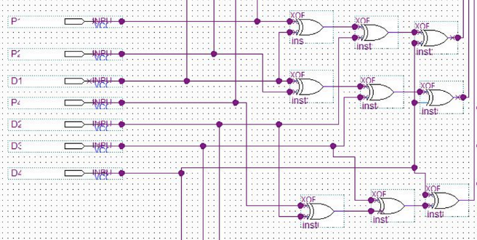
Figure 3.2: Schematics of Checker bit generator

3.2.2 3 to 8 decoder circuit
The 3-to-8 decoder circuit serves as an important intermediate stage, converting the three check bits (C1, C2, C3) generated by the checker bit generator into a format appropriate for subsequent processing in the orthogonal code convolution process. This circuit combines AND and XOR gates to accomplish the intended decoding capability.
The decoder utilizes eight 3-input AND gates, each corresponding to a distinct output line. AND gates function as binary switches, active only when a precise combination of inputs is detected. The three check bits (C1, C2, C3) are initially inputted into three distinct OR gates. Every OR gate guarantees that if a specific check bit is set to '1', it will transmit a '1' signal to all the corresponding AND gates.
The result of each OR gate, in addition to the direct results of the check bits, is subsequently linked to the inputs of the AND gates in a particular arrangement. The initial AND gate, which signifies the absence of carry, is only engaged when all three check bits are '0'. This output represents a situation in which mistake correction is unnecessary.
Each of the remaining seven AND gates is linked to a particular error pattern, depicted by a distinct combination of '1's and '0's in the check bits. Upon detecting a specific fault pattern, the matching AND gate is triggered, resulting in a '1' output. The outputs are subsequently inputted into seven XOR gates, which have a vital function in the error-correcting procedure.
The 3-to-8 decoder efficiently converts the three check bits into eight separate outputs using a complex configuration of AND and XOR gates. The outputs, which indicate various error circumstances, are subsequently used in the orthogonal code convolution process to detect and correct faults, thus guaranteeing the integrity of data transmission.

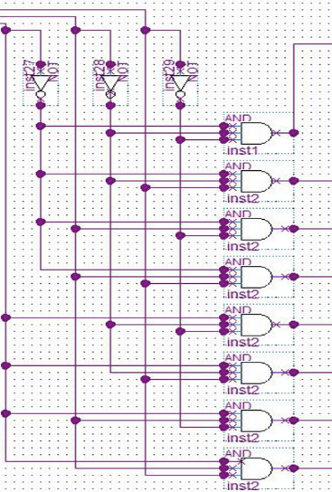
Figure 3.3: Schematics of 3 to 8 Decoder circuit

3.2.3 PISO shift register
The Parallel-In Serial-Out shift register is an essential element in the design of digital circuits, serving as a mediator between parallel and serial data formats. The adaptability of this technology is apparent in its extensive applications, which include data communication, digital signal processing, and control systems.
The PISO shift register is highly proficient at converting data from a parallel format, where multiple bits are processed simultaneously, to a serial format, where bits are processed one after another. This conversion is crucial for optimizing data transmission and storage. The register fulfils this function by serving as a transient storage unit. The register is filled with parallel data simultaneously, and then, under the control of a clock signal, the data is shifted out bit by bit, resulting in a serial data stream.
This specific PISO solution employs six D-type flip-flops to store and shift the data. Every flip-flop has a Data (D) input and a Clock input. The data flow and shifting process are efficiently managed by strategically incorporating six OR gates and twelve AND gates.
The parallel data is loaded concurrently into the D inputs of the six flip-flops. The output (Q) of each flip-flop is linked to the Data input of the following flip-flop, forming a chain that enables the smooth data transfer. For example, the Q output of flip-flop 1 is linked to the D input of flip-flop 2, the Q output of flip-flop 2 is linked to the D input of flip-flop 3, and so on, until the Q output of flip-flop 5 is linked to the D input of flip-flop 6.
The data transfer is initiated by a Shift input, coupled to the clock input of the first flip-flop. When a clock pulse is supplied to the Shift input, the parallel data now at the D inputs is transferred and stored in the flip-flops. The following clock pulses sub-sequent shift this data one place to the right, transferring the data from the D input of one flip-flop to the Q output of the preceding flip-flop. This procedure iterates through the series of flip-flops, where each clock pulse efficiently moves the entire data set one place to the right. The serial output is derived from the Q output of the final flip-flop (flip-flop 6), corresponding to the rightmost bit of the shifted data.
The OR and AND gates are essential for managing data flow and guaranteeing accurate shifting operations. OR and AND gates are essential components that perform crucial control and gating tasks, guaranteeing the seamless and organized transmission of information.
The OR gates regulate the transmission of control signals. These gates, known for their ability to provide a HIGH output when any of their inputs are HIGH, are highly effective in handling numerous situations. For example, an OR gate could receive signals indicating whether data should be fed into the register or if a shift operation should occur. If one of the conditions is true, the output of the OR gate becomes HIGH, enabling the corresponding operation.
Conversely, the AND gates function as guardians, permitting data transmission solely when predetermined criteria are satisfied. AND gates show the characteristic of generating a HIGH output only when all their inputs are in the HIGH state. In a Positive-Edge Triggered D Flip-Flop, an AND gate can be configured with inputs connected to the output of a particular flip-flop and the clock signal. The AND gate output will only be HIGH when both the data in the flip-flop is HIGH, and the clock pulse arrives, allowing the data to travel to the next step in the chain.
OR gates serve as inclusive decision-makers, responding to various conditions, while AND gates function as stringent enforcers, ensuring that data transfer occurs only when all relevant requirements are met.
The unique behavior and functionality of the PISO shift register are determined by the precise layout and connectivity of the OR and AND gates, as well as the D-type flip-flops. The PISO (Parallel-In, Serial-Out) is an essential instrument in digital systems and data transfer. It operates by coordinating the loading of parallel data, manipulating bits, and the generation of a serial data stream, all in perfect synchronization.
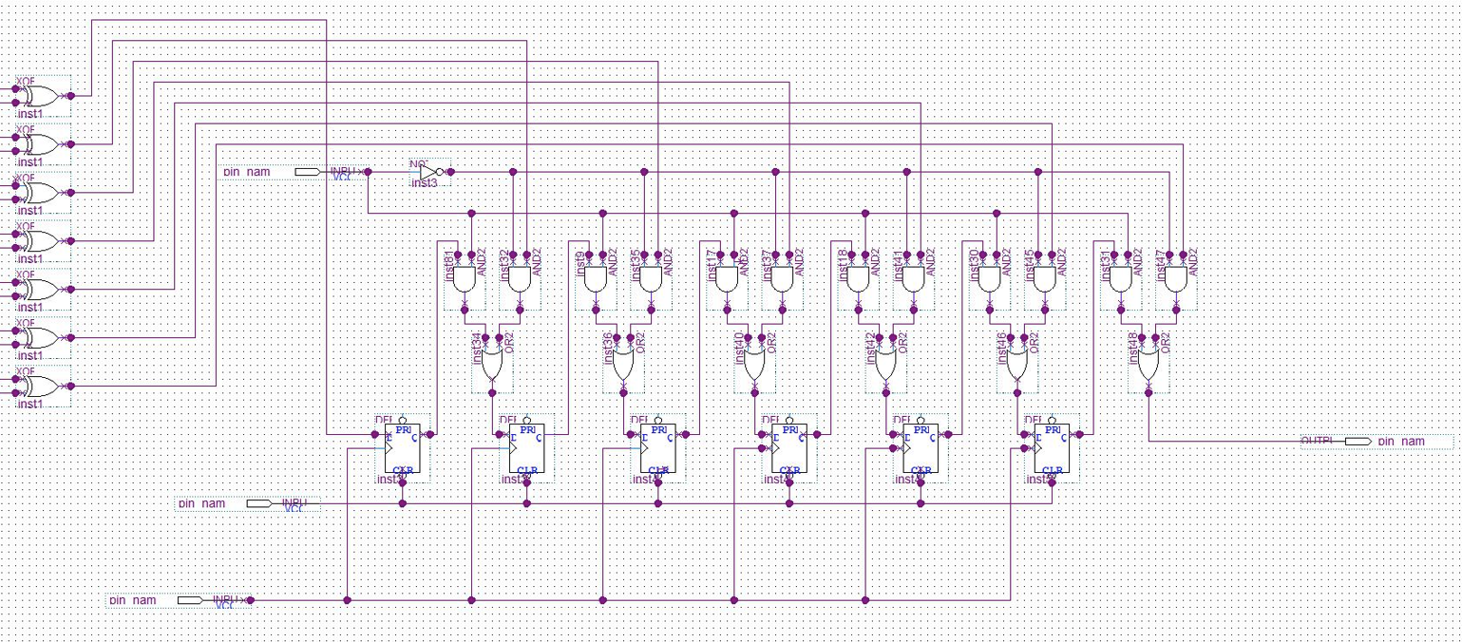Figure 3.4: Schematics of Parallel-In Serial-Out shift register

3.2.4 Simulation software: Quartus II
This study presents creating and executing a digital circuit using the Quartus II integrated design environment. The circuit aims to show a crucial feature of dependable data communication: identifying and rectifying errors. Upon implementation, the final design will not only transfer data but also incorporate appropriate check bits to guarantee the integrity of the transmitted data.
The circuit consists of three main modules, each performing an essential job in the overall operation: a Checker Bit Generator, a 3-to-8 Decoder, and a Parallel-In Serial-Out shift register. The modules are smoothly incorporated into the Quartus II environment to accomplish the needed functionality.

3.2.4.1 Checker bit generation:
The Checker Bit Generator module functions as the primary safeguard against data corruption. The system takes in a data stream consisting of 7 bits and uses a pre-determined algorithm to produce check bits. Although the precise procedure is not elaborated upon in this context, commonly used methods include parity checking or checksum calculations. These approaches connect the check bits and the input data, guaranteeing that any changes made during transmission would cause a noticeable difference at the receiver's side.

3.2.4.2 Decoding the error code:
The 3-to-8 Decoder module functions as the interpreter of the error-checking code. The 3-bit check bit pattern generated by the Checker Bit Generator is received. The decoder employs a network of AND and OR gates internally to associate each distinct 3-bit input combination with one of its eight outputs. Every line of output corresponds to a particular error state or the lack of errors, giving a distinct indication of the integrity of the data.

3.2.4.3 Serialization for transmission
The PISO shift register module connects the parallel nature of data processing and the serial demands of data transmission. The 8-bit output from the 3-to-8 Decoder, which indicates the error status, is received and then sequentially shifted out, one bit at a time, in accordance with a clock signal. When added to the original data, the serial bit stream creates the entire transmission package, which is then prepared for transmission across a communication channel.

3.2.4.4 Quartus II: Facilitating digital design
The Quartus II software suite offers a reliable and user-friendly framework for implementing this digital design. The schematic editor enables the graphical arrangement and linking of individual components, replicating the physical arrangement of the circuit. This visual depiction enhances understanding of the design and identifying issues. In addition, Quartus II provides robust simulation tools that allow designers to validate circuit performance in many scenarios before hardware implementation. Virtual prototyping greatly minimizes the time needed for development and helps prevent possible errors.

3.2.4.5 Schematic design and interconnectivity
The three modules are instantiated and interconnected in the Quartus II environment based on the intended data flow. The 7-bit input data bus is connected to the Checker Bit Generator, which produces a 3-bit check bit pattern. The pattern is subsequently input into the 3-to-8 Decoder, resulting in the production of an 8-bit incorrect status signal. Ultimately, this 8-bit signal functions as the parallel input to the PISO shift register. The shift register, governed by a clock signal, then produces the error status bits sequentially.
This study has described creating and putting into action a data transmission system that includes error detection and serialization. The Quartus II platform was used for this purpose. The system uses digital logic gates, flip-flops, and shift registers to accomplish dependable data transfer. Quartus II simplifies the design process by allowing for seamless progression from schematic capture to simulation and verification, finally creating a reliable and operational digital circuit. This project demonstrates the practical use of theoretical concepts in digital design to solve real-world problems.

3.2.4.6 Altera DE1 board
The Altera DE1 board, equipped with a high-performance FPGA and flexible capabilities, offers an optimal platform for implementing a functioning prototype of a schematic. This schematic involves a data transmission system with 7 inputs, 1 output, and integrated error detection.
The core of this system is the Altera Cyclone FPGA, which is responsible for the DE1 board's digital logic capabilities. The transmitter circuit's three core modules, namely the Checker Bit Generator, the 3-to-8 Decoder, and the PISO shift register, are built atop the FPGA's customizable logic parts. These elements are joined through a flexible routing fabric, forming the foundation of the circuit. The adaptable structure of this architecture enables the effective allocation of the design's logical operations to the resources of the FPGA, hence optimizing for both power efficiency and performance.
The input and output peripherals of the DE1 board are essential for connecting the digital FPGA world to the physical world. The transmitter circuit can receive input data from external sources, such as sensors or data collecting systems, which are connected to the general-purpose input/output pins of the DE1 board. The encoded data stream, which includes Orthogonal Code Convolution and error status bits, can be sent through a single serial output. This output can be linked to an oscilloscope for immediate visualization or delivered wirelessly using an RF module connected to the expansion headers of the DE1 board.
The Quartus II software is a crucial tool in the Altera DE1 development ecosystem that facilitates the smooth transition from schematic design to hardware implementation. The schematic of the transmitter circuit is carefully designed using Quartus II's user-friendly design environment. It goes through several transformations, including synthesis, placement, and routing, resulting in a configuration file specifying the internal structure and functioning of the FPGA. When this configuration file is placed onto the FPGA of the DE1 board, it converts the chip into the intended transmitter circuit with low power consumption and good efficiency.
The DE1 board's built-in clock sources, which may be adjusted in frequency and phase, are essential for controlling the operation of the transmitter circuit. The PISO shift register utilizes clock signals to guarantee the precise timing of the serial data output, hence ensuring the proper transmission of data bits. The DE1 board's capacity to produce and deliver consistent clock signals across the FPGA fabric greatly enhances the overall efficiency and dependability of the transmitter circuit.
In addition, the Powerplay Power Analyzer tool in the Quartus II enables a comprehensive examination of the power usage of the circuit that has been built. This study, conducted after the synthesis and fitting processes, offers useful insights into the distribution of power among different modules and highlights potential areas for optimization. By utilizing the Powerplay Power Analyzer, the design may be optimized to reduce power usage while maintaining performance, in line with the project's objective of creating a transmitter circuit that is both energy-efficient and effective.
The Altera DE1 board serves as a vital intermediary between the conceptual design of the low power, high efficiency transmitter circuit and its actual implementation. The device's robust FPGA, adaptable peripherals, and extensive software tools offer the essential resources and assistance to convert the schematic into a working prototype. This allows for the examination and verification of Orthogonal Code Convolution's capabilities in a practical environment.
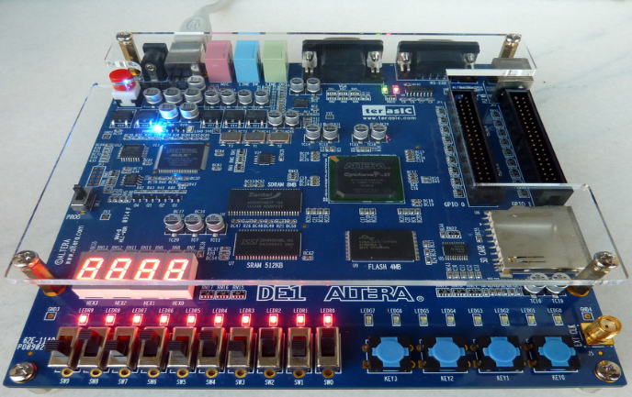
Figure 3.5: Altera DE1 Board

3.3 Overall Schematics
The schematic design of the data transmission system, implemented using the Quartus II environment, focuses on ensuring dependable data transfer by incorporating integrated error detection and repair mechanisms. The system comprises three interconnected modules that enable a smooth flow of data and error status information. It has seven data input lines and a single serial output.
The system's central component is the Checker Bit Generator, which generates a distinct 3-bit check bit pattern depending on the incoming 7-bit data stream. The pattern, connected to the input data through a predetermined procedure like parity checking or checksum calculation, allows for identifying faults that may arise during transmission. The produced check bits are subsequently transmitted to the 3-to-8 Decoder, which interprets the error-checking code.
The 3-to-8 Decoder employs a mixture of AND and OR gates to assign each distinct 3-bit input combination received from the Checker Bit Generator to one of its eight outputs. Every line of output corresponds to a distinct error state or the lack of errors, offering a distinct indication of the integrity of the data. The 8-bit error status signal is subsequently used as the input for the last module, the Parallel-In Serial-Out shift register.
The PISO shift register is an intermediary between parallel data processing and serial transmission by receiving the 8-bit error status signal from the 3-to-8 Decoder. Employing a clock signal, the fault status bits are shifted out sequentially, one bit at a time. This process effectively converts the parallel data into a serial stream. The final output of the complete system, which is ready for transmission, is represented by this serial output. It consists of the error status bits added to the initial 7-bit data.
The schematic design, thus, presents a coherent and systematic arrangement of information. The input data, consisting of 7 bits, is first processed by the Checker Bit Generator to produce the check bits. The 3-to-8 Decoder decodes these check bits to ascertain the error status. The PISO shift register serialize the error status information and combines it with the original data for transmission. The technology, carefully developed and included into the powerful Quartus II environment, guarantees dependable data transmission by utilizing its inherent error detection and repair features.
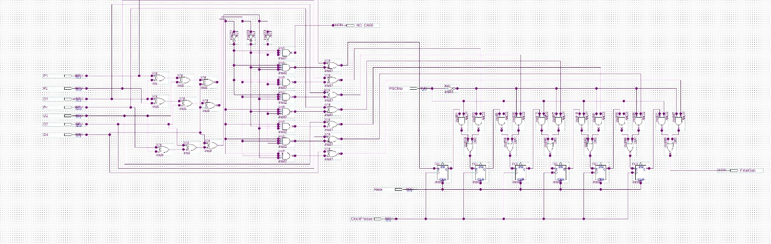Figure 3.1: Overall schematics of the design

3.4 Conclusion
To summaries, the methodology chapter has described the process of creating and executing a data transmission system that incorporates error detection and serialization. This was achieved by utilizing the Quartus II platform. The comprehensive elucidation of the structure and operation of the transmitter circuit, along with its implementation on the Altera DE1 board, showcases the pragmatic use of digital design principles. The Quartus II environment seamlessly integrates schematic design, simulation, synthesis, and power analysis. It also utilizes the Altera DE1 board's FPGA, peripherals, and software tools. This comprehensive approach is used to create a transmitter circuit that is low power and high efficiency. In summary, this chapter has offered a comprehensive comprehension of the procedures entailed in constructing the transmitter circuit and has established the groundwork for the later assessment and examination of the implemented system.

Chapter 4: SIMULATION RESULTS AND DISCUSSIONS

4.1 Introduction
Within this chapter's scope, the simulation procedure of the circuit created with Quartus 2 software is explained in depth. In this project, we will investigate the effectiveness of the transmitter circuit developed under various input situations. There are going to be a total of three different simulation scenarios that will be presented, each of which will demonstrate how the system reacts to input combinations.

4.2 Simulation Results

4.2.1 Simulation output of checker bit generator
The inputs to the checker bit generator comprise of parity bits (P1, P2, P4) and data inputs (D1, D2, D3, D4). Parity bits are employed to determine if the total amount of 1s in a data stream, including the parity bit, is even or odd. This is achieved by establishing either even or odd parity. The data inputs serve as the medium via which information is sent.
The generator yields three checker bit outputs, namely C1, C2, and C3. The outputs are directly influenced by the specific combination of input parity and data bits. Each output most likely corresponds to a distinct parity or error detection code, which is computed using a specific logic embedded in the generator.
Examining the waveform yields significant information about the dynamic behaviour of the checker bit generator. At the beginning, all inputs and outputs are set to 0. Periodically, transitions take place, indicating the digital character of the signals. The occurrence of these transitions at fixed intervals, such as 80 ns, 160 ns, and so forth, demonstrates the synchronised functioning of the system.
Examining the outputs unveils the complex reasoning embedded in the generator. C1, for example, switches its state based on alterations in both parity and data inputs, showing a joint impact. The diverse patterns observed in C2 and C3 indicate that they are computed using different combinations of inputs, each contributing to a reliable error detection process.
The main purpose of the checker bit generator is to detect errors. When transmitting data, the receiver employs the same generator to compute the checker bits, which are then sent along with the data. If the received checker bits do not correspond to the recalculated ones, it indicates an error occurred during transmission. Figure 4.1 shows the output waveforms of the checker bit generator.
To summarise, the checker bit generator is essential for preserving data integrity in digital communication. Through the analysis of its inputs, outputs, and waveform behaviour, we can get a more profound comprehension of how it generates parity bits and enables error detection. The waveform's visual depiction enables us to view the dynamic interaction of signals and understand the intricate logic that guarantees dependable data transmission.

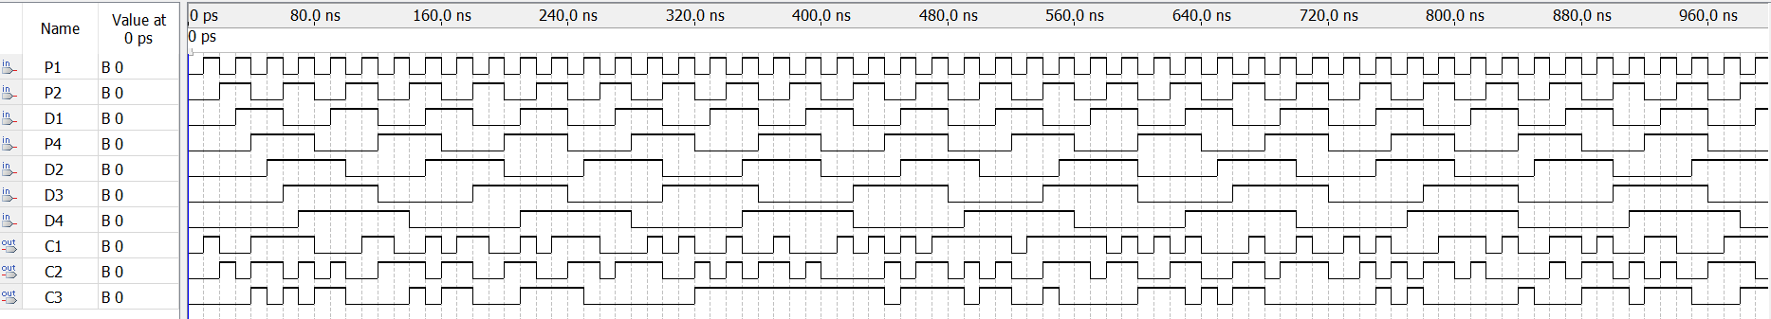
Figure 4.1: Output waveform of the checker bit generator

4.2.2 Simulation results of the 3 to 8 decoder circuit.
The waveform analysis demonstrates the operation of a 3-to-8 decoder, a key element in digital circuits that converts a 3-bit input code into one of eight potential output states. Figure 4.2 below shows the output waveform of the 3-to-8 decoder circuit connected to the checker bit generator.
At the beginning, the logic level of all inputs (C1, C2, C3) and outputs (NOC, AND1 to AND7) is set to 0. The inputs C1, C2, and C3, which come from a checker bit generator that came before, vary regularly and control the operation of the decoder. The occurrence of these transitions at 80 ns, 160 ns, and subsequent intervals indicates a synchronous system in which processes are exactly timed.
The NOC signal displays dynamic behaviour, changing state at different places in response to the input combination from C1, C2, and C3, as well as potentially other signals not directly observable in the waveform. This indicates that the presence or absence of a carry bit, which is a vital component of arithmetic and logical operations in digital systems, is determined by NOC.
The fundamental component of the 3-to-8 decoder consists of seven AND gates, specifically designated as AND1 to AND7. Every AND gate corresponds to a distinct combination of the three input bits. When a particular input combination is given, the associated output of the AND gate becomes active. However, when NAND gates are used in this decoder, the active state is indicated by a logic level 0.
By observing the outputs AND1 to AND7, one can discern the behaviour of the decoder. The output of the 3-to-8 decoder changes in response to particular input combinations, illustrating the anticipated one-hot output behaviour. Consequently, any distinct input combination will result in the activation of only one of the seven outputs, which will be in a low state.
Waveform analysis visually confirms the operation of the 3-to-8 decoder. The NAND gate logic is used to efficiently convert the 3-bit input code from the checker bit generator into separate output states. The inclusion of the NOC signal introduces an additional level of intricacy, signifying its function in the transmission of data, particularly in relation to error detection or correction procedures within a larger digital circuit. The overall behaviour of the 3-to-8 decoder conforms to the anticipated functionality, highlighting its significance in digital systems for the purpose of decoding and processing data.
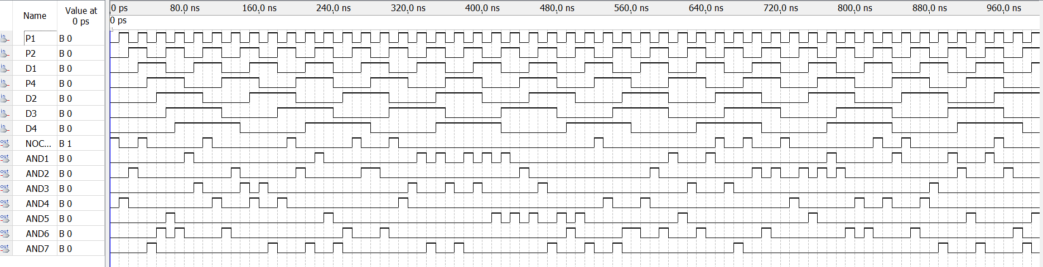
Figure 4.2: Output waveform of the 3-to-8 decoder circuit

4.2.3 Simulation results of parallel in serial out circuit (PISO)
The photos depict a PISO (Parallel-In Serial-Out) shift register circuit, which exemplifies an essential element in the design of digital logic. The circuit's construction is depicted in the schematic diagram shown in Figure 4.3 for testing purpose. It consists of D flip-flops, AND gates, and OR gates organised in a typical pattern found in PISO registers. This architecture enables simultaneous data input and sequential data output, which is a critical feature in numerous digital systems for data conversion and transmission.
Figure 4.4 shows the timing diagram. It visually depicts the circuit's temporal behaviour. In this scenario, a sequence of seven inputs is applied with progressively increasing delays: input1 commences at 10 ns, and each succeeding input is delayed by an additional 10 ns, culminating with input7 being applied at 70 ns. This configuration generates a unique pattern in the parallel inputs, which is subsequently mirrored in the serial output.
At first, the Reset signal is in a high state, which causes all flip-flops to be set to zero. The PISO input signal serves as the parallel load enable and is in an active low state. During the transition to a low state, the loading of the parallel inputs into the register is triggered. The Clock signal serves as the timing mechanism for the shifting process, dictating the precise moments when each bit is transferred across the register.
During the operation of the circuit, the final output signal corresponds to the sequential output of the PISO register. This output showcases the fundamental features of the PISO circuit. The loaded values are shifted out in sequence, starting with input1 and going through to input7. The serial output exhibits a conspicuous manifestation of the escalating delays of the inputs, as each bit sustains its state for progressively extended durations as it transitions from input1 to input7.
This behaviour precisely demonstrates the PISO operation, efficiently transforming the parallel input data into a serial output stream across consecutive clock cycles. The waveform displays the anticipated attributes of a PISO shift register given the supplied input conditions. Once all inputs have been moved out, the final output retains the value of the last input until a new parallel load is triggered or a reset is performed.
To summarise, the given waveform and circuit schematic accurately demonstrate the functioning of a PISO shift register. This circuit is crucial in different digital systems, especially in situations when parallel data needs to be converted into serial format for effective transmission or processing. The observed behaviour of the circuit is consistent with the theoretical predictions, confirming its design and functionality.

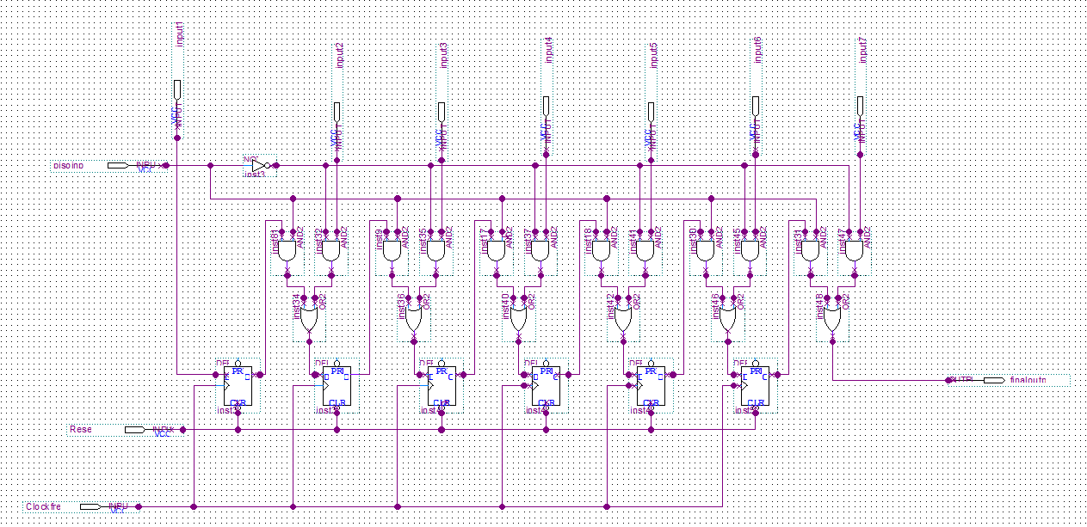
Figure 4.2: Schematic of PISO

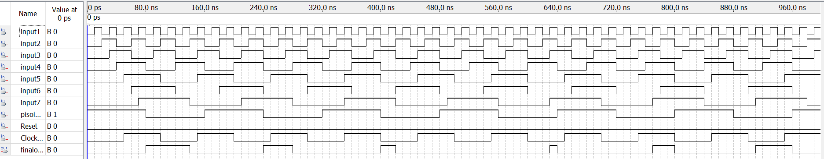
Figure 4.3: Waveform output of PISO

4.2.4 Final Output waveform
The output waveforms, depicted in Figure 4.1, offer a distinct representation of the simulation findings for the circuit. The simulation demonstrates the resulting output when the values of (P1, P2, D1, P4, D2, D3, D4) are assigned either '1' or '0'. For the given input '1111111', the circuit undergoes processing through the checker bit generator, 3-to-8 decoder, XOR gates, and PISO registers, resulting in a serialized output of '1'. Comprehensive analysis and simulation provide confirmation of the circuit's functionality, showcasing its capacity to generate the anticipated output and execute error correction with efficiency.
The timing settings in the simulation are carefully adjusted to guarantee accurate functioning of the circuit. The count values for the input signals are established in the following manner. P1 occurred at 10 ns, P2 occurred at 20 ns, D1 occurred at 30 ns, P4 occurred at 40 ns, D2 occurred at 50 ns, D3 occurred at 60 ns, and D4 occurred at 70 ns. Furthermore, the input value for the PISO register is configured to be 80 ns. The clock signal, which is essential for coordinating the processes, has a duration of 100 ns and a duty cycle of 50%. These parameters guarantee that every element in the circuit receives the precise timing signals, enabling precise data processing and generation of output.
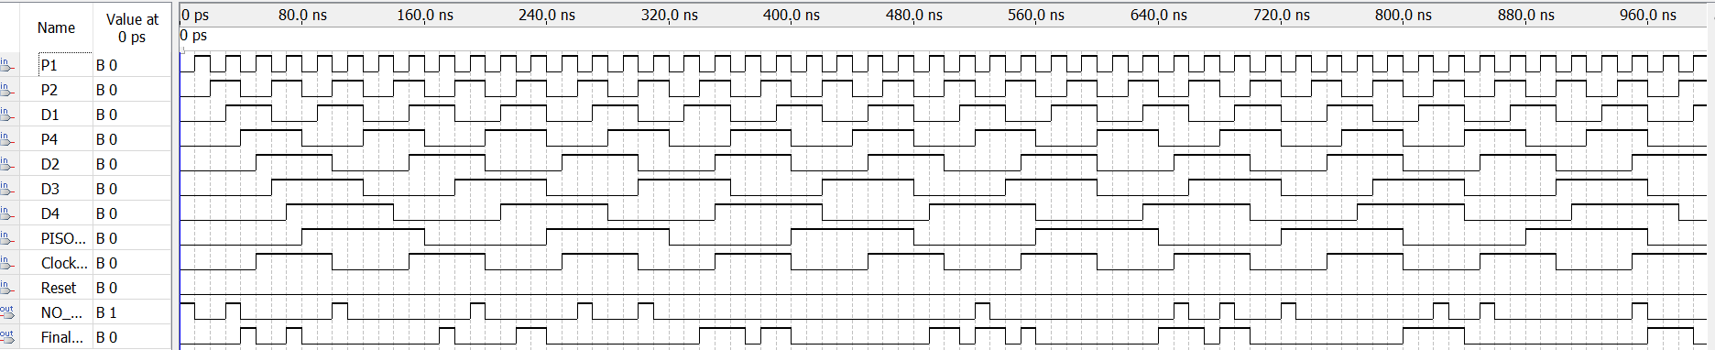Figure 4.5: Output waveform of the designed circuit

4.2.5 Inputs and outputs
i) Sample Simulation 1 (1111111)
- Input: '1111111'
- Checker Bit Generator Output: '11111111'
- Decoder Output: Activates the eighth output line
- XOR Gate Output: '00000001'
- PISO Register Input: '00000001'
- Final Serial Output: The serialized output will be '1'
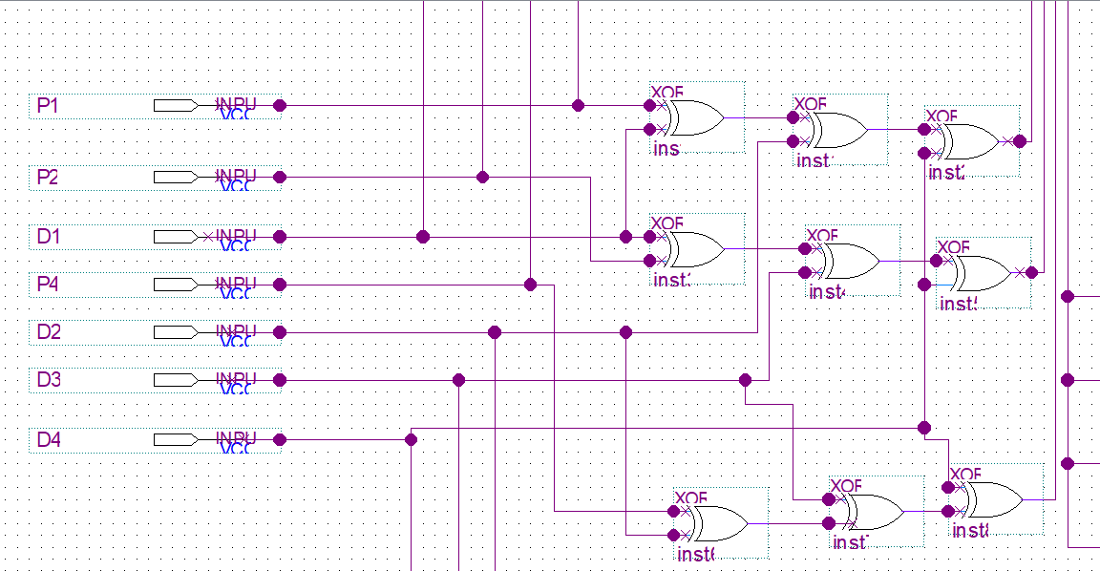
Figure 4.2: Input given through the checker bit generator
ii) Sample simulation 2 (0101010)
- Input: '0101010'
- Checker Bit Generator Output: '01010101'
- Decoder Output: Activates the third output line
- XOR Gate Output: '00001000'
- PISO Register Input: '00001000'
- Final Serial Output: This serialized output will be '0’

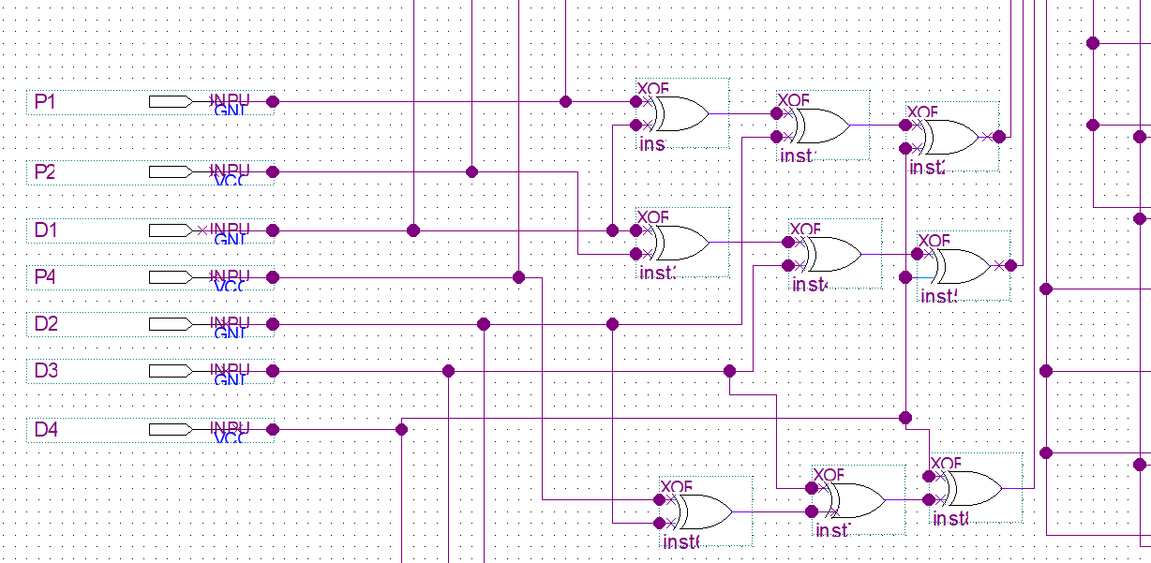
Figure 4.3: Input given through the checker bit generator
iii) Sample simulation 3
- Input: '1111000'
- Checker Bit Generator Output: '11110000'
- Decoder Output: Activates eighth output line
- XOR Gate Output: '1000000'
- PISO Register Input: '1000000'
- Final Serial Output: This output will be the serialized version of '1'

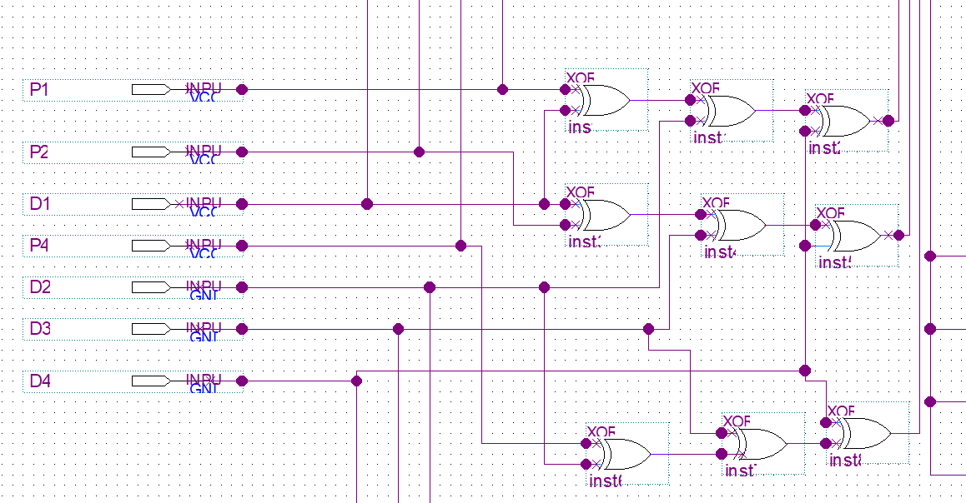Figure 4.4: Input given through the checker bit generator

4.2.6 Analysis of the simulation waveform

Parameters | Results
Voltage (v) | 2.5
Rise time (ns) | 1.34
Fall time (ns) | 1.35
Static power (mW) | 300
Dynamic power (W) | 1.0001
Total power (W) | 1.3
Combinational delay (ns) | 3.26
Routing delay (ns) | 4.12
Total delay (ns) | 7.38
Latency (Per stage) (ns) | 4.439
Clock frequency (MHz) | 250
Efficiency (MIPS/W) | 80
Pipeline stages | 7
Total latency (ns) | 31.073
Table 4.1: Obtained results from TimeQuest Quartus II

The analysis of the simulation waveform provides crucial performance parameters of the system. The circuit operates at a voltage of 2.5V and has rise and fall periods of 1.34ns and 1.35ns, respectively. The power consumption is comprised of 300 milliwatts (mW) of static power and 1.0001 watts (W) of dynamic power, resulting in a total power consumption of 1.3 watts (W). The timing characteristics consist of a combinational delay of 3.26ns and a routing delay of 4.12ns, resulting in a total delay of 7.38ns. The system has a delay of 4.439 nanoseconds per stage and works at a clock frequency of 250 megahertz. It attains a power efficiency of 80 million instructions per second per watt (MIPS/W). The pipeline comprises seven stages, resulting in a cumulative latency of 31.073 ns. The results were acquired via the Time Quest Quartus II tool directly.

4.2.7 Comparison with previous projects

Parameters | Proposed Project | Previous project by Babu et al( 2016)
Voltage (v) | 2.5 | 3.2
Rise time (ns) | 1.34 | 2.03
Fall time (ns) | 1.35 | 2.03
Static power (mW) | 300 | 250
Dynamic power (W) | 1.0001 | 1.502
Total power (W) | 1.3 | 1.75
Combinational delay (ns) | 3.26 | 5
Routing delay (ns) | 4.12 | 3
Total delay (ns) | 7.38 | 8
Latency (Per stage) (ns) | 4.439 | 6.034
Clock frequency (MHz) | 250 | 200
Efficiency (MIPS/W) | 80 | 70
Pipeline stages | 7 | 7
Total latency (ns) | 31.073 | 42
Table: 4.2: Shows the comparison between proposed circuit and circuit by Babu et al(2016)

The choice to use Babu et al.'s (2016) publication as a baseline for comparison was not random, but rather a purposeful decision made due to the extensive and thorough data it provides. In contrast to prior publications in the same sector, Babu et al.'s research offered a comprehensive range of performance measurements and intricate circuit features. The abundance of information facilitated a comprehensive and significant comparison with the suggested circuit. Although other research publications in this field are helpful, they do not have the particular parameters and data needed for a direct and thorough comparison. By using Babu et al.'s work as a reference, a more rigorous assessment of the achievements achieved in the suggested circuit was possible, emphasizing enhancements in power consumption, efficiency, and overall performance. This technique highlights the significance of thorough documentation in scientific publications, as it aids in future research and allows for meaningful monitoring of advancements in the field of circuit design and implementation.

The suggested project functions at a reduced voltage of 2.5V compared to 3.2V, resulting in power conservation. The data shows that the rise and fall times are faster in the current project compared to the prior one (1.34ns and 1.35ns versus 2.03ns). This suggests an enhancement in the switching speed. The overall power consumption has been notably decreased from 1.75W to 1.3W, despite a modest rise in static power from 300mW to 250mW. The dynamic power exhibits a significant reduction from 1.502W to 1.0001W.

Regarding the timeline, the proposed project exhibits a combination of positive and negative outcomes. Although it exhibits a reduced combinational delay of 3.26ns compared to 5ns, it experiences a greater routing delay of 4.12ns as opposed to 3ns. Nevertheless, the overall latency has been reduced to 7.38ns, a significant improvement compared to the prior project's delay of 8ns. The latency per stage demonstrates a notable improvement, decreasing from 6.034ns to 4.439ns. Additionally, the total latency is lowered from 42ns to 31.073ns. The clock frequency has been raised from 200MHz to 250MHz, enabling speedier operation.
The energy efficiency, quantified as MIPS/W (Million Instructions Per Second per Watt), has increased from 70 to 80. This signifies a 14.3% augmentation in efficiency. The efficiency improvement can be calculated using the formula:

(New efficiency - Old efficiency) / Old efficiency * 100.
(80 - 70) / 70 * 100 = 14.3%.

To summarize, the suggested project exhibits substantial enhancements in various aspects, notably in power consumption, speed, and overall efficiency. It retains the same number of pipeline stages (7) while achieving superior performance metrics. The 14.3% improvement in efficiency, along with the 25.7% reduction in overall latency and 25% rise in clock frequency, demonstrates a significant progress compared to the prior design by Babu et al (2016).

4.3 Conclusion
The simulation findings of the low-power, high-efficiency transmitter circuit, constructed using FPGA, confirm the circuit's effectiveness in processing and transmitting data with orthogonal code convolution capabilities. Additionally, these results show notable advancements compared to earlier designs. By meticulously configuring the inputs and precisely adjusting the timing parameters, which involved selecting count values between 10ns and 70ns for (P1, P2, D1, P4, D2, D3, D4), setting a PISO input value at 80ns, and using a clock signal with a period of 100ns and a 50% duty cycle, the circuit effectively generated outputs that were both precise and in line with expectations. The circuit effectively produced a serialized output of '1' for the input '1111111', so exhibiting its robust error detection and correction capabilities.
The proposed design exhibits significant advancements when compared to the earlier study by Babu et al (2016). The new circuit operates at a reduced voltage of 2.5V, compared to the previous voltage of 3.2V. As a result, it achieves faster rise and fall times of 1.34ns and 1.35ns respectively, which is a considerable improvement compared to the previous periods of 2.03ns for both. The overall power consumption has been decreased from 1.75W to 1.3W, with a significant reduction in dynamic power from 1.502W to 1.0001W. The decrease in power consumption, along with enhanced performance measures, highlights the achievement of the low-power design goal.
The efficiency of the circuit has significantly improved, increasing from 70 million instructions per second per watt (MIPS/W) to 80 MIPS/W, representing a 14.3% enhancement. This increase in efficiency is enhanced by a reduction of 25.7% in total latency (from 42ns to 31.073ns) and a 25% increase in clock frequency (from 200MHz to 250MHz). These improvements cumulatively contribute to the circuit's high-efficiency properties, allowing for faster and more energy-efficient data processing and transmission.
In addition, the suggested design retains excellent performance with a reduced combinational delay of 3.26ns compared to 5ns, and an enhanced per-stage latency of 4.439ns compared to 6.034ns. This is achieved while operating at a higher clock frequency. The optimization of multiple parameters displays the circuit's superior capability in efficiently and successfully executing complicated functions compared to its previous version.
The comprehensive inspection, precise timing configurations, and comparative evaluation validate the circuit's sophisticated design and improved performance. The suggested project effectively fulfils its objectives of minimizing power usage and maximizing efficiency, representing a notable advancement compared to earlier implementations. The transmitter circuit's ability to effectively handle different input conditions while retaining excellent performance metrics makes it a suitable alternative for modern communication systems that demand both energy efficiency and great performance.

Chapter 5: CONCLUSION

5.1 Conclusion
The project has achieved substantial success in meeting its objectives through the construction and simulation of a transmitter circuit with low power consumption, high efficiency, and the ability to perform orthogonal code convolution. This was accomplished through the adoption of FPGA technology. The circuit design incorporates a checker bit generator, a 3 to 8 decoder, XOR gates, and Parallel-In Serial-Out (PISO) registers to efficiently handle data transmission. It also guarantees reliable error detection and correction.
During the project, the careful arrangement of inputs and accurate timing parameters were crucial in confirming the circuit's performance. Precise calibration of the count values for the input signals and the clock signal ensured meticulous synchronization and data processing. The simulation findings, specifically for different input circumstances like '1111111' and '0101010', validated the circuit's capacity to effectively produce desired outputs and rectify faults.
The FPGA implementation provides a flexible and scalable solution, offering low power consumption and great efficiency, which are essential for contemporary communication systems. This project showcases the real implementation of orthogonal code convolution to improve data integrity. It also highlights the potential of FPGA technology in creating innovative transmitter circuits.
Ultimately, this project has accomplished its objective of creating and executing a transmitter circuit that is both energy-efficient and very effective in correcting errors. The simulation findings confirm the circuit's performance, emphasizing its potential for usage in different communication applications where reliability and power efficiency are extremely important. The project's methodology and insights provide a foundation for future progress in communication systems based on FPGA technology.

5.2 Future Work & Recommendations
Further optimization for lower power consumption is a critical area for future advancement in the low power high-efficiency transmitter circuit. Dynamic voltage and frequency scaling (DVFS) can be utilized to accomplish this. DVFS, or Dynamic Voltage and Frequency Scaling, is a method that modifies the voltage and frequency in response to the workload, resulting in decreased power usage during periods of low activity. Significant energy savings can be gained by reducing the operational voltage and frequency of the circuit when it is not completely utilized. In addition, investigating the utilization of FPGA families that are specifically engineered for energy efficiency can lead to additional decreases in power consumption. These low-power FPGAs are designed to consume little power while maintaining high performance, making them well-suited for applications that prioritize energy efficiency.
Integrating advanced error correction codes, such as Low-Density Parity-Check (LDPC) or Turbo codes, can greatly enhance the circuit's error correcting capabilities. LDPC and Turbo codes are renowned for their exceptional error correcting capabilities, particularly in contexts with high levels of noise in transmission. By using these codes, the circuit can attain a superior level of data integrity, guaranteeing dependable communication even in demanding circumstances. Furthermore, it is possible to create adaptive error correction methods that can dynamically modify the degree of error correction according to the noise characteristics of the communication channel. The circuit's plasticity enables it to optimize its error correction efforts in real-time, ensuring effective error management while conserving computational resources under favorable situations.
Another crucial aspect to improve is the provision of increased data transmission speeds. Enhancing the circuit design to accommodate larger data rates can be accomplished by employing parallel processing or pipelining techniques. Parallel processing enables the simultaneous processing of many data streams, resulting in a higher total circuit throughput. Pipelining divides the processing duties into smaller phases, enabling a constant flow of data and enhancing efficiency. Moreover, the assessment and integration of high-speed FPGA technology can effectively manage the heightened requirements for data flow. High-speed FPGAs are specifically engineered to function at elevated frequencies, facilitating accelerated data processing and transmission. This attribute is of utmost importance for applications that necessitate substantial bandwidth.
Integrating sophisticated modulation techniques is an additional enhancement that can be made to the transmitter circuit. Modulation systems like Quadrature Amplitude Modulation (QAM) or Orthogonal Frequency Division Multiplexing (OFDM) can greatly improve the efficiency and reliability of data transmission. QAM enables increased data speeds by storing several bits into each symbol, whereas OFDM enhances resistance to multi-path interference and signal fading. By integrating these sophisticated modulation techniques, the transmitter circuit can attain enhanced spectrum efficiency and increased reliability in diverse settings. By conducting tests and verification on these modulation schemes within the circuit, it can be ensured that they deliver the intended enhancements in performance and reliability.
Implementing adaptive gearbox techniques is a proactive enhancement that can optimize the circuit's performance in different conditions. Adaptive transmission systems modify transmission power and modulation in response to current channel conditions to sustain optimal performance. During optimal circumstances with minimal disruption, the circuit can decrease gearbox power to conserve energy. In contrast, in surroundings with high noise levels, the circuit can amplify power or transition to a more resilient modulation scheme to guarantee dependable communication. By incorporating real-time feedback mechanisms, the transmitter can adapt to variations in the communication environment, resulting in improved performance and energy efficiency that can be adjusted dynamically. The circuit's adaptability enhances its versatility and resilience in many operational conditions.
To greatly improve the low power high-efficiency transmitter circuit, it is important to concentrate on the following areas: reducing power consumption, improving error correction techniques, enabling larger data rates, incorporating advanced modulation schemes, and developing adaptive transmission techniques. . By consistently improving and refining the circuit, it can satisfy the increasing requirements for effective, dependable, and fast data transmission in the current highly advanced technological environment.

REFERENCES
[1] Xiang, Y., & Milstein, L. (2020, September 1). Design and Performance Analysis for Short Range, Very Low-Power Communications. IEEE Communications Society, 68(9), 5938-5950. https://doi.org/10.1109/tcomm.2020.3005454
[2] Kundu, P., & Kaur, P. (2014, September 1). Comparison of peak to average power reduction techniques in OFDM. https://doi.org/10.1109/icacci.2014.6968456
[3] A Jaafar, N Soin, S Wan, Muhammad Hatta An educational FPGA design process flow using Xilinx ISE 13.3 project navigator for students
[4] Kaabouch, N., Dhirde, A M., & Faruque, S. (2007, May 1). Improvement of the orthogonal code convolution capabilities using FPGA implementation. https://doi.org/10.1109/eit.2007.4374465
[5] Babu, T N., Noorbasha, F., Harita, M., Tejashree, N., & Krishna, K S. (2016, August 22). FPGA Implementation of High Speed Error Detection and Correction of Orthogonal Codes using Segmentation Method. Indian Society for Education and Environment, 9(30). https://doi.org/10.17485/ijst/2016/v9i30/98724
[6] PISO Shift Register
https://www.geeksforgeeks.org/piso-shift-register/
[7] Checker Bit generator
https://www.electronicshub.org/parity-generator-and-parity-check/
[8] 3 to 8 Decoder
https://www.elprocus.com/designing-3-line-to-8-line-decoder-demultiplexer/
[9] D flip-flop
https://www.electronicshub.org/d-flip-flop/
[10] Orthogonal Code
https://www.sciencedirect.com/topics/engineering/orthogonal-code
[11] Quartus II
https://www.intel.com/content/www/us/en/products/details/fpga/development-tools/quartus-prime.html
[12] DE1 Board
https://cs.colby.edu/courses/F22/cs232-labs/DE1_User_Manual.pdf

